**INTERNATIONAL SCHOOL OF   
MANAGEMENT AND TECHNOLOGY**

**FACULTY OF COMPUTING**

**ASSIGNMENT COVER SHEET**

*This form is to be completed by students submitting assignments of level 4 and level 5. Students are required to complete all sections and attach to your assignment.*

|  |  |
| --- | --- |
| STUDENT DETAILS | |
| STUDENT NAME | BISHAL THAPA |
| STUDENT ID | 2023CA05 |

|  |  |  |  |
| --- | --- | --- | --- |
| UNIT AND ASSIGNMENT DETAILS | | | |
| UNIT TITLE | Unit 13: Website Design & Development | | |
| UNIT NUMBER | Y/618/7419 | | |
| ASSIGNMENT TITLE | Gorkha Martial Arts | | |
| ISSUE DATE | 18/07/2023 | DUE DATE | 17/09/2023 |
| ASSESSOR NAME | Amrit Gurung | | |
| ESTIMATED WORD LENGTH | 8000 | | |

|  |  |
| --- | --- |
| SUBMISSION | |
| HAND IN DATE | 17/09/2023 |

**DECLERATION AND ACKNOWLEDGEMENT**

***When submitting assignments, each student must sign a declaration confirming that the work is their own.***

***Plagiarism and Collusion***

**Plagiarism:** to use or pass off as one’s own, the writings or ideas of another without acknowledging or crediting the source from which the ideas are taken.

**Collusion:** submitting an assignment, project or report completed by another person and passing it off as one’s.

In accordance with the*Academic Integrity and Plagiarism Policy*:

1. **I declare that:**
2. this assignment is entirely my own work, except where I have included fully-documented references to the work of others,
3. the material contained in this assignment has not previously been submitted for any other subject at the University or any other educational institution, except as otherwise permitted,
4. no part of this assignment or product has been submitted by me in another (previous or current) assessment, except where appropriately referenced, and with prior permission from the Lecturer / Tutor / Unit Coordinator for this unit.
5. **I acknowledge that:**
6. if required to do so, I will provide an electronic copy of this assignment to the assessor;
7. the assessor of this assignment may, for the purpose of assessing this assignment:
8. reproduce this assignment and provide a copy to another member of academic staff;
9. communicate a copy of this assignment to a plagiarism checking service such as Plagiarism Check (which may then retain a copy of this assignment on its database for the purpose of future plagiarism checking).

|  |  |  |  |
| --- | --- | --- | --- |
| I am aware of and understand that any breaches to the Academic Code of Conduct will be investigated and sanctioned in accordance with the College Policy. | | | |
| SIGNATURE | BISHAL THAPA | DATE | 17/09/2023 |

Table of Contents

Executive Summary 1

Introduction 1

DNS Server 1

Types of DNS Server 2

1. DNS Recursive Resolver 2

2. DNS Root Server 2

3. TLD Nameserver (Top-Level Domain) 2

4. Authoritative DNS Server 3

Domain names are organized and managed 3

Relationships between hardware and software in website 3

1. Communication Protocols 3

2. Server Hardware 4

3. Operating Systems 4

4. Web Server Software 4

1. Design Phase 4

2. Publishing Phase 5

3. Access Phase 5

An analysis of how web development technologies and frameworks 5

Web Development Technologies 5

1. HTML5 5

2. CSS 6

3. Javascript 7

4. PHP 7

5. jQuery 8

6. React 8

7. Angular 9

Impact on Web Design 9

Impact on Functionality 10

Impact on Management 10

SEO (Search Engine Optimization) 11

1. Crawling 11

2. Indexing 12

3. Ranking 12

Improving Website Index Value through Effective SEO 12

1. Relevant and Quality Content 12

2. Metadata and Keywords 12

3. Performance and Page Speed 13

4. Proper Links and Linking Between Pages 13

5. Resource Optimization 13

Front-end Development 13

Back-end Development 14

Discussion of Front-end and Back-end Capabilities and Relationships 14

Relationship to Presentation and Application Layers 14

An analysis of the impact of different tools and techniques available on custom-built website design and development 15

Tools Analysis: 15

1. Visual Studio Code (VS Code): 15

2. Babel (JavaScript Transpiler): 16

3. Chrome DevTools: 16

4. Google Page Speed Insights: 16

5. Adobe XD (Prototyping): 17

Techniques Analysis: 17

1. Responsive Web Design: 17

2. User-Centered Design (UCD): 18

3. Comprehensive SEO Techniques: 18

4. Performance Optimization: 18

5. Security Protocols: 19

6. Social Media Integration: 19

Online Website Creation Tools 19

Custom-Built Sites 20

Conclusion 21

Client Requirements 22

User Requirements 22

Functional Requirements 22

Non-Functional Requirements 22

User Acceptance Criteria 23

Wireframe 23

Home page Before Login Wireframe 23

User Register wireframe: 26

User Login wireframe: 26

Home Page after login User wireframe: 27

Account (User Profile) wireframe: 29

Interface Design 30

Interface Design of Home Page Before Login 30

User Register Interface Design: 34

User Login Interface Design: 35

Menubar After User Login Interface Design 35

Subscription Plan After Login Interface Design 36

My Plan Interface Design 36

Forget password Interface Design 37

Account Profile Interface Design 37

Networking Considerations 37

1. Domain Name and DNS Configuration 37

2. SSL Certificate and HTTPS 38

3. Content Delivery Network (CDN) 38

4. Network Security 39

5. Database Connectivity 39

Hosting Considerations 39

1. Hosting Type 39

2. Server Location 39

3. Server Performance and Resources 39

4. Scalability 40

5. Backup and Recovery 40

6. Technical Support 40

7. Content Management System Compatibility 40

8. Uptime and Reliability 40

Security features that could be implemented in the Gorkha Martial Arts 40

1. SSL/TLS Encryption 40

2. User Authentication Security 41

3. Regular Software Updates 41

4. Web Application Firewall 41

5. Regular Backups 41

Accessibility and inclusivity guidelines implementation 41

1. Semantic HTML Markup 41

2. Descriptive Alt Text for Images 42

3. Keyboard Navigation and Focus States 42

4. Color Contrast 43

5. Responsive and Flexible Design 43

6. Accessible Forms and Error Handling 44

Test Plan 45

Registration and Login Functionality 45

Account Update 45

Contact Us Form 46

Membership Options and Prices 46

Membership Purchase 47

Website Responsiveness 48

Explanation of the web design principles, standards and guidelines 49

Web Design Principles 49

Web Design Standards 49

Web Design Guidelines 50

Executive Summary 50

Introduction 50

A justification of the implementation of the multi-page website decisions against the planned design decisions. 51

An implementation of the test plan against the final developed multi-page website 52

Quality Assurance and Quality Assurance Process 53

QA implemented during the design and development stages of the multi-page website 53

Justification of chosen management services, tools and software 54

Evaluation of Design and Development Process 56

1. Requirements Gathering and Analysis 56

2. Client Consultation 56

3. Conceptualization and Wireframing 56

4. Design and User Interface (UI) Development 56

5. Front-End Development 56

6. Back-End Development 57

7. Content Integration 57

8. Testing and Quality Assurance 57

9. Client Review and Feedback 57

10. Launch and Deployment 57

Evaluation of Specific Technical Challenges Faced in Creating the Gorkha Martial Arts Website 58

1. Responsive Design and Cross-Device Compatibility 58

2. Integration of Complex Features 58

3. Security and Data Protection 59

4. Performance Optimization 59

5. SEO and Accessibility Compliance 59

6. User Feedback Implementation 59

7. Cross-Browser Compatibility 59

Evaluation of the results of the Test Plan and the overall success of the Gorkha Martial Arts website 60

Overall Success of the Gorkha Martial Arts Website 61

1. User Engagement and Interaction 61

2. Membership Growth 61

3. Positive Brand Perception 61

4. Reliable Functionality 61

5. Continual Enhancement 61

Recommended improvements for the Gorkha Martial Arts website based on client feedback and testing results: 62

1. Enhanced Mobile Experience 62

2. Streamlined Membership Sign-Up Process 62

3. Improved Class Scheduling Visualization 62

4. Interactive Instructor Profiles 62

5. Engaging Community Platform 63

Conclusion 63

References 63

Figure 1: DNS Server 0

Figure 2: HTML5 4

Figure 3: CSS 5

Figure 4: Javascript 5

Figure 5: PHP 6

Figure 6: JQuery 6

Figure 7: React 7

Figure 8: Angular 7

Figure 9: Search Engine Optimization (SEO) 9

Figure 10: Wordpress 16

Figure 11: Wireframe Home page part 1 19

Figure 12: Home page wireframe part 2 20

Figure 13: Home page wireframe part 3 20

Figure 14: Home page wireframe part 4 21

Figure 15: Home page wireframe part 5 21

Figure 16: User Register wireframe 22

Figure 17: User Login Wireframe 22

Figure 18: Home page wireframe after Login part 1 23

Figure 19: Home page wireframe after login part 2 23

Figure 20: Home page after login part 3 24

Figure 21: Home Page After login part 4 24

Figure 22: Home page after login part 5 25

Figure 23: Account Profile wireframe 25

Figure 24: Menubar Before Login in website 26

Figure 25: Program in Website 26

Figure 26: Subscription Panel Before Login part 1 26

Figure 27: Subscription Panel Before Login part 2 27

Figure 28: Feature of Website 27

Figure 29: Class Timetable in Website 27

Figure 30: Instructor Details in Website 28

Figure 31: About Us Page in Website 28

Figure 32: Testimonials in Website 28

Figure 33: Online Video in Website 29

Figure 34: Contact Us and Social Integration in website 29

Figure 35: Footer in Website 29

Figure 36: Register in Website 30

Figure 37: Login in Website 30

Figure 38: Menubar After Login in Website 31

Figure 39: Subscription Plan in website part 1 31

Figure 40: Subscription Plan in website part 2 31

Figure 41: My Plan In website 32

Figure 42: Forget Password in Website 32

Figure 43: Login Account Update Image 32

Figure 44: Connection Secure SSL HTTPS 33

Figure 45: CDN Figure 34

Figure 46: HTML MARKUP 37

Figure 47: Image Alt Text 37

Figure 48: Keyboard Navigation 38

Figure 49: Color Constrant 38

Figure 50: Responsive Design 39

Figure 51Error Handling Image 39

Figure 52: Registration Testing Plan 40

Figure 53: Account Update Testing Plan 41

Figure 54: Membership Price Display Testing Plan 42

Figure 55: Membership Purchase Testing 43

Figure 56: Responsive Testing Plan 43

# Executive Summary

This comprehensive report explores various aspects of web development, including DNS servers, hardware-software relationships, domain management, SEO strategies, web development technologies, and the impact of tools and techniques on custom-built websites. It also compares online website creation platforms to custom-built sites, highlighting design flexibility, performance, functionality, user experience, and user interface considerations. Ultimately, the report underscores the importance of thoughtful tool and technique choices in delivering a successful, highly customized website for Gorkha Martial Arts.

# Introduction

In today's digital age, a strong online presence is crucial for businesses and organizations to thrive. The purpose of this report is to explore the technologies that can be utilized to develop, host, and manage the website for Gorkha Martial Arts, a martial arts training center. In this report we will explore areas such, as managing domains, the relationship between hardware and software technologies used in web development optimizing search engine visibility, front end and back end technologies, tools for designing websites and the difference between online website creation platforms and custom built sites.

# DNS Server

The DNS server plays a role, on the internet by converting user domain names, such as www.google.com into numeric IPs like 192.168.1.1. This conversion is vital for enabling communication, between computers. DNS ensures easy access to websites without remembering numeric IPs. Users input domains in browsers, and the DNS server translates them into IP addresses. It's a distributed database, simplifying translation between memorable names and numeric addresses crucial for networking. Without DNS, the internet would be complex, less user-friendly, requiring numeric IPs for each site (Michael Dooley, 2017).

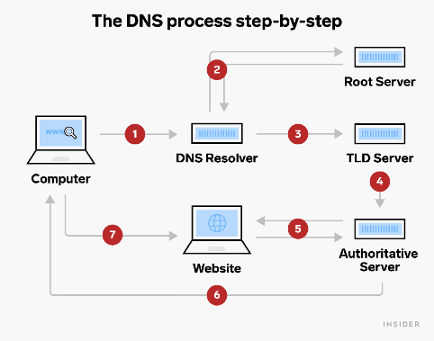

Figure 1: DNS Server

# Types of DNS Server

## DNS Recursive Resolver

A DNS recursive resolver is vital in the DNS hierarchy, aiding users in obtaining domain-related IP addresses. When a user's device seeks a domain, the resolver queries DNS servers systematically, including root DNS, top-level domain servers, and authoritative DNS. It compiles data to fulfill the user's request and simplifies DNS resolution, managing hierarchy complexities for users.

## DNS Root Server

The DNS resolution process heavily relies on the participation of DNS root servers, which act as the initial point of contact. They store records of IP addresses for authoritative DNS servers linked with each top-level domain (TLD). The main goal is to guide DNS queries accurately to the respective TLD nameservers. Despite their limited count, these root servers ensure a stable and resilient DNS infrastructure, supporting the seamless operation of internet navigation.

## TLD Nameserver (Top-Level Domain)

Top Level Domain (TLD) Nameservers play a role, in managing domains at the level. They are responsible for overseeing top level domains like.com.org and.net, as country code domains specific to certain countries like .np. Every TLD possesses its own set of authoritative nameservers. When a recursive resolver contacts a TLD nameserver, it supplies details about the authoritative nameservers for the second-level domain within that TLD. These TLD nameservers play a vital role in guiding DNS queries to the appropriate authoritative nameservers accountable for the requested domain, progressing the DNS resolution process.

## Authoritative DNS Server

An authoritative DNS server is the one that maintains the accurate and current DNS records, for a domain. These records encompass essential information, such as domain name-associated IP addresses, mail server addresses, and other relevant DNS data. When a DNS resolver needs information about a domain name it reaches out to the DNS server for that specific domain. The resolver requests the up to date and accurate IP address information, from the server. This allows the resolver to obtain the up, to date and accurate IP address details. The goal is to retrieve precise and current IP address details. In essence, the authoritative DNS server stands as the ultimate source of truth regarding the DNS records of a particular domain. Its role is to ensure accurate responses to DNS queries.

# Domain names are organized and managed

Domain names are organized and managed through a hierarchical structure known as the Domain Name System. This system organizes domain names into levels, where the top level domain is located on the rightmost part, like.com or.org. Beneath TLDs are second-level domains, like google in google.com. These second-level domains are registered with domain registrars, organizations authorized to manage domain name registrations. Domain registries maintain databases containing information about the registered domain names within a specific TLD. Each domain registrar interacts with the corresponding domain registry to update, renew, or transfer domain names on behalf of users. ICANN is the organization for managing domain names is tasked with overseeing the functioning and security of the global domain name system to maintain stability and proper operation (Pope, 2012).

# Relationships between hardware and software in website

The relationships between hardware and software in designing, publishing, and accessing the Gorkha Martial Arts website are crucial for its functionality and user experience. This interplay involves various components and technologies, including communication protocols, server hardware, operating systems, and web server software.

## Communication Protocols

Communication protocols define the rules and procedures for data exchange between different devices. HTTPS (Hypertext Transfer Protocol Secure) ensures secure data transmission over the internet through encryption, making sensitive information safe during user interactions. Conversely FTP (File Transfer Protocol) facilitates effortless file transfer, between devices assisting in the uploading and managing of website content (Sidna, 2020) .

## Server Hardware

Server hardware refers to the physical equipment that hosts and serves the website's content to users. This hardware includes powerful processors, ample memory, and storage capacity. Examples of server hardware include servers or cloud based instances offered by providers such, as AWS, Microsoft Azure or Google Cloud Platform.

## Operating Systems

Operating systems act as intermediaries between the server hardware and software applications, managing resources and facilitating communication. They ensure efficient resource allocation and provide a stable environment for software execution. Examples of operating systems encompass Windows Server, Linux distributions like Ubuntu, CentOS, and Debian (Wang, 2004).

## Web Server Software

Web server software is responsible for processing and serving web resources to users' browsers. Different software options offer varying features and performance capabilities. For example: Apache is an open-source web server known for its adaptability and ability to be customized. Tomcat is tailored for Java-based web applications. IIS (Internet Information Services) is a Microsoft server software designed for Windows environments. Nginx has gained recognition for its performance, in managing connections and its use as a reverse proxy (Menasce, 2003).

Throughout the life cycle of the Gorkha Martial Arts website, these components work together seamlessly. The server hardware stores the website's data, and the chosen operating system ensures everything runs smoothly. The web server software takes care of requests from users and provides the right content, while communication protocols make sure data is secure and files are transferred efficiently.

This dynamic interaction is noticeable when the website is being created, published, and accessed

## Design Phase

When building the website, developers use software tools like canva and programs like Visual Studio Code to design the look, graphics, and functions. These tools need powerful computers to handle the complex design tasks (Flavian, 2009).

## Publishing Phase

To put the website on the internet, hosting providers use server hardware, operating systems, and communication protocols. They upload files securely using methods like FTP or SFTP. The web server software then handles requests from users' browsers and delivers the content.

## Access Phase

During the access phase, when users navigate to the Gorkha Martial Arts website, the web server receives their requests and interacts with the database server. This database server contains dynamic content managed by a Database Management System (DBMS) and PHPMYADMIN. The interaction takes place through Structured Query Language (SQL) commands, ultimately culminating in the interactive experience that users observe on their screens.

By effectively managing the relationships between these hardware and software components, the Gorkha Martial Arts website can deliver a seamless and secure user experience while enabling efficient content management and updates.

# An analysis of how web development technologies and frameworks

## Web Development Technologies

### HTML5

HTML5 is the latest version of the foundational markup language for web content. It introduces semantic elements for headers, navigation menus, articles, and footers, improving accessibility, SEO, and page comprehension. It enables multimedia integration without plugins, supporting audio, video, and intricate graphics via the canvas element. HTML5 supports responsive design and offline capabilities through features like Application Cache and Web Storage, delivering an interactive user experience (Tabares, 2021).

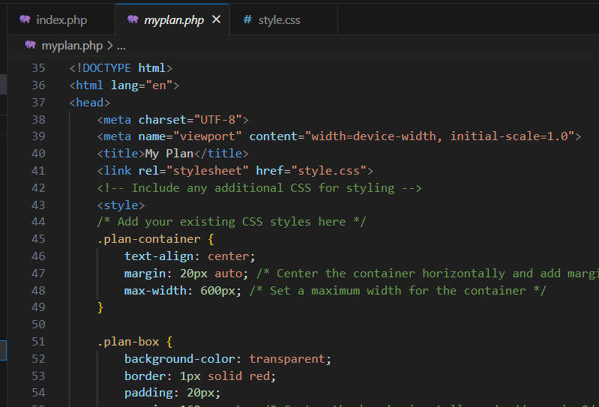

*Figure 2: HTML5*

### CSS

CSS controls web page presentation. Applying CSS rules to HTML elements defines colors, typography, spacing, and visuals. Selectors target elements for styling, while properties customize them. CSS is vital for responsive design, adapting content to screens. Layout tools like Flexbox and CSS Grid enhance control, enable animations, transitions, and enrich UX. Preprocessors like SASS and LESS streamline CSS by adding variables and nesting (Blansit, 2008).

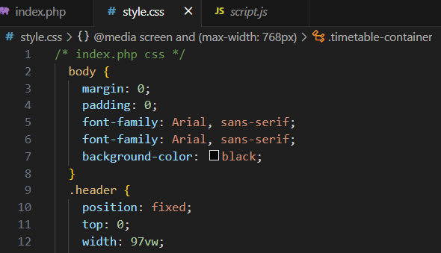

*Figure 3: CSS*

### Javascript

JavaScript powers dynamic web interactivity, changing page elements in response to user actions. From button clicks to complex tasks like form validation and AJAX data fetching, libraries like React, Angular, and Vue.js offer pre-built components for intricate web apps.

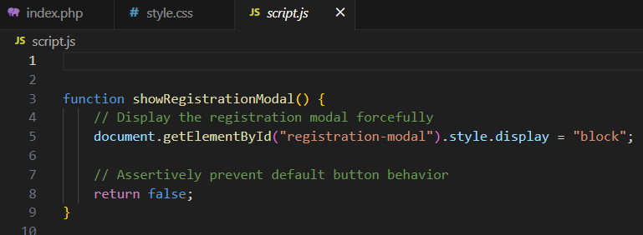

*Figure 4: Javascript*

### PHP

PHP is a server-side scripting language generating HTML on the server before sending it to the client's browser. Integrated with databases like MySQL, PHP retrieves and stores data, pivotal for content management systems and data-driven apps. PHP seamlessly combines with HTML, creating versatile pages. Frameworks like Laravel provide standardized structures for building robust applications (Siame, 2017).

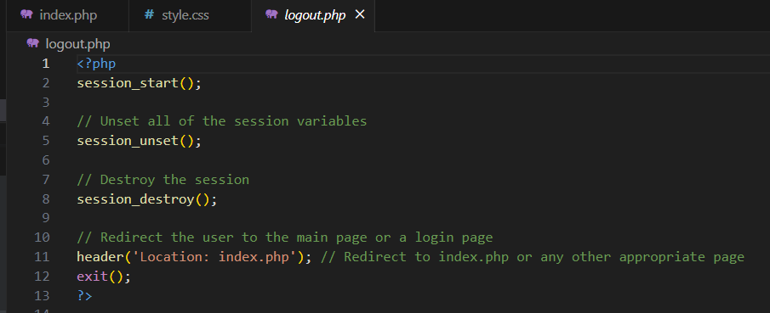

*Figure 5: PHP*

### jQuery

jQuery simplifies client-side scripting, streamlining HTML interaction, DOM manipulation, event handling, animation creation, and asynchronous requests. It reduces the need for extensive code and abstracts complexities.

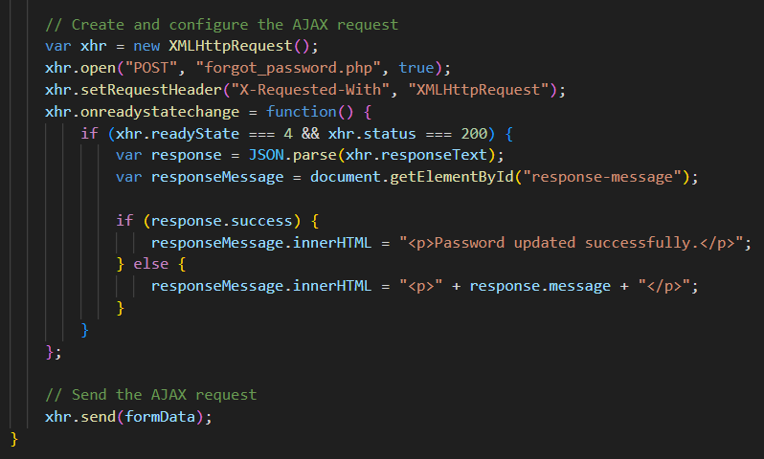

*Figure 6: JQuery*

### React

React, originated from Facebook, is a JavaScript library that empowers developers to craft user interfaces by reusing components. It employs a strategy aimed at optimizing updates to the Document Object Model (DOM) by utilizing a Virtual DOM, which in turn enhances overall performance. Reacts focus on component-based architecture encourages modularity and the ability to reuse code.

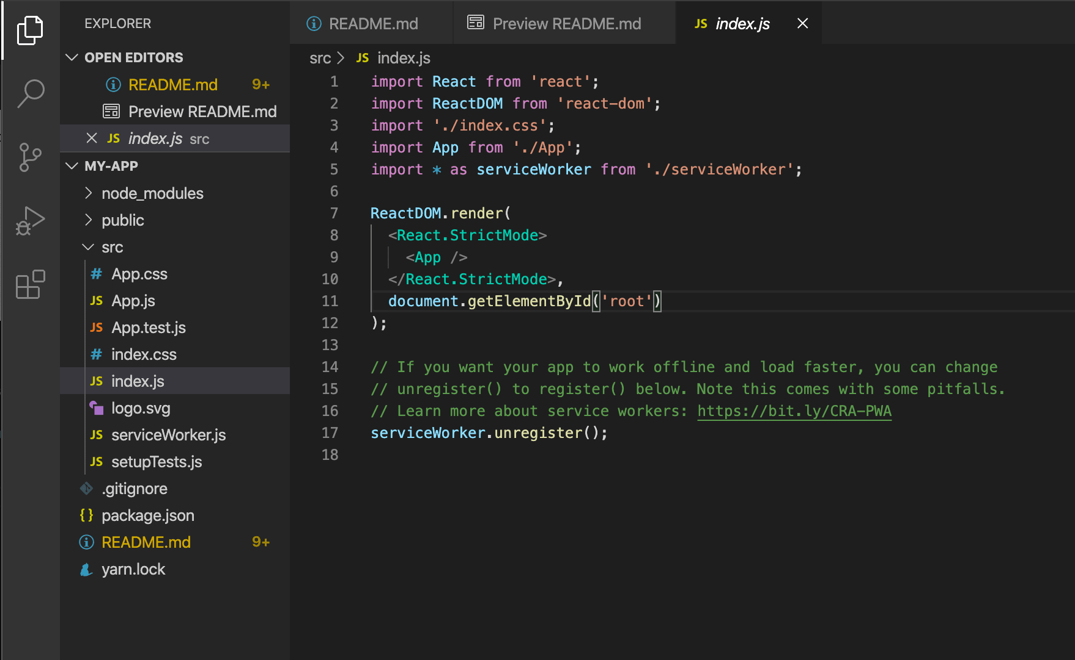

*Figure 7: React*

### Angular

Angular, developed by Google is a JavaScript framework that enables developers to build web applications both, for single page and large-scale purposes. It is structured around components offers advantageous features such as dependency injection, two-way data binding, as well as robust tools, for managing routing, forms and state control.

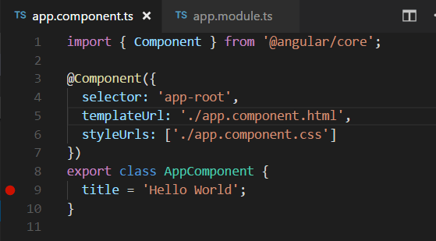

*Figure 8: Angular*

## Impact on Web Design

The advent of web development technologies and frameworks has led to a profound transformation in web design practices. Developers now have the tools to create websites that seamlessly adapt to various devices and screen sizes. This adaptability is facilitated by frameworks like Bootstrap and CSS media queries, ensuring a consistent user experience across different platforms. Component-based architectures, notably exemplified by React and Angular, enable the creation of modular UI components. This modular approach not only promotes a consistent design but also expedites development through the reuse of components. It also supports iterative design enhancements and A/B testing, fostering user-centered design practices. Furthermore, the integration of HTML5 and dynamic JavaScript libraries like jQuery and React has ushered in a new era of interactivity and visual appeal. Websites now incorporate animations and micro-interactions, providing engaging user experiences. Additionally, adherence to HTML5's semantic structure enhances accessibility and boosts search engine optimization, leading to improved discoverability (Jongmans, 2022).

## Impact on Functionality

Web functionality has undergone a significant transformation, driven by the integration of web development technologies. Real-time data updates, championed by frameworks like React and Vue.js, have enabled dynamic content refreshing without the need for page reloads. This not only reduces latency but also significantly enhances user engagement. The rise of Single Page Applications (SPAs), thanks to frameworks like Angular and React, has resulted in faster load times and smoother navigation. Asynchronous programming, exemplified by Node.js, plays a pivotal role in enhancing application performance. It prevents process blockages during data retrieval, ensuring the website remains responsive even under heavy user loads. Moreover, the seamless integration of JSON and APIs has empowered web applications to incorporate third-party services effortlessly. This expansion of capabilities without reinventing the wheel collectively contributes to an enriched functionality of web applications (Tandon, 2017).

## Impact on Management

The adoption of web development technologies and frameworks has not only impacted the technical aspects of web development but has also revolutionized management practices. Framework standardization has promoted collaboration among team members, enabling them to work cohesively and understand each other's code more efficiently. Component-based architectures have fostered the creation of modular and maintainable code, enhancing adaptability. Dependency management tools such as npm and yarn have accelerated development by allowing teams to focus on unique functionalities without getting bogged down by intricate details. Version control systems like Git and continuous integration practices have further facilitated collaboration, efficient code reviews, and the stability of web applications. Additionally, web technologies provide crucial support for scalability and performance monitoring. Optimization tools aid in identifying and addressing performance issues, ensuring optimal user experiences even during high-traffic periods (Obradovic, 2014).

# SEO (Search Engine Optimization)

SEO (Search Engine Optimization) involves the process of enhancing your website to attain improved rankings in search engine outcomes. It encompasses various strategies, beginning with keyword research to identify terms users frequently search for. Then, on-page optimization involves integrating these keywords naturally into your content and meta tags. Content creation is crucial, aiming to provide valuable and informative material that satisfies user queries. Ensuring your site is technically sound, or technical optimization, aids search engine crawlers in navigating your pages smoothly. Building backlinks from authoritative sources bolsters your site's credibility. The user experience is also pivotal, focusing on easy navigation and fast loading times. Continuous monitoring and analysis of your performance, coupled with adjustments following search engine algorithm updates, refines your approach. Ultimately, SEO propels your website up the search engine results pages, boosting organic traffic and visibility, and aligning your content with user intent (Yalçın, 2010).

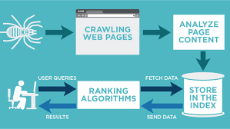

*Figure 9: Search Engine Optimization (SEO)*

In the SEO (Search Engine Optimization), there are three important things that happen to decide how much a website shows up when you search: crawling, indexing, and ranking.

## Crawling

This initial step involves search engine bots, also known as crawlers or spiders, systematically exploring the internet's vast web of interconnected pages. Crawlers navigate through websites by tracking links from one page to another, collecting information, and evaluating content. They scrutinize not only the text but also images, videos, and other elements. By crawling, search engines create a comprehensive map of the web's content.

## Indexing

Once the crawlers gather information from various websites, this data is indexed, which essentially means it's organized and stored in a massive database. Indexing categorizes content based on keywords, topics, and other relevant attributes. Indexing makes it possible for search engines to quickly retrieve relevant results when users input search queries.

## Ranking

After indexing, the search engine employs intricate algorithms to evaluate and determine the order in which websites should appear in response to a user's search query. The aim is to prioritize the presentation of the most relevant and high-quality content initially. Ranking factors include keyword relevance, content quality, user engagement metrics, backlinks, site speed, and mobile-friendliness. Websites that meet these criteria are given rankings increasing their chances of appearing at the top of search results (Long, 2006).

In essence, crawling locates content, indexing organizes it, and ranking assigns priority based on relevancy and quality. These interconnected processes underpin the functioning of search engines, shaping the way users access information and the visibility of websites within the digital landscape.

# Improving Website Index Value through Effective SEO

In today's digital landscape, a robust online presence is contingent upon a website's index value – a key metric that directly influences search engine visibility and organic traffic. This review delves into the strategies and practices that substantively boost a website's index value through meticulous SEO efforts, backed by clear and well-documented evidence (Setiawan, 2020).

## Relevant and Quality Content

A cornerstone of SEO success, crafting relevant and high-quality content significantly contributes to a website's index value. Creating content that is well researched, informative and captivating has an impact, on the intended audience. It enhances user engagement. Encourages visitors to spend time on the website. Case studies of websites that have adopted this approach consistently report improved index value, as evidenced by higher organic traffic and reduced bounce rates.

## Metadata and Keywords

Optimizing metadata with pertinent keywords directly impacts a website's index value. Using selected keywords and seamlessly incorporating them into title tags meta descriptions and header tags can significantly boost the contents relevance, for search engines. Analyzing case studies showcases a clear correlation between keyword optimization and improved index value, often leading to higher rankings for targeted search queries.

## Performance and Page Speed

Numerous studies have revealed the pronounced effect of website performance and page speed on index value. Websites that implement strategies to enhance loading times, such as optimizing media files, consolidating CSS and JavaScript files, and leveraging browser caching, consistently demonstrate improved index value scores. This is substantiated by the observed decrease in bounce rates and enhanced user experience.

## Proper Links and Linking Between Pages

Evidence suggests that effective linking practices directly contribute to a website's index value. Internal links that connect relevant pages provide a clear structure for search engine crawlers, positively influencing indexation. Furthermore, case studies highlight that external links to authoritative sources amplify a website's credibility, resulting in higher index value and improved organic rankings.

## Resource Optimization

Research affirms that efficient resource utilization directly correlates with a website's index value. Streamlining code, implementing Gzip compression, and leveraging browser caching effectively reduce page load times. This optimization is validated by studies that showcase notable improvements in index value, as indexed pages become more accessible and responsive, resulting in enhanced search engine visibility.

In conclusion, the evidence-backed review emphasizes that a holistic approach to SEO, incorporating relevant and high-quality content, metadata optimization, performance enhancement, proper linking practices, and resource optimization, tangibly enhances a website's index value. Numerous case studies provide clear documentation of the positive impact these strategies have on organic traffic, user engagement, and search engine rankings. Adhering to these practices equips website owners and marketers with a roadmap to elevate their index value and establish a strong online presence (Ziakis, 2019).

# Front-end Development

Front-end development involves crafting user interfaces and visual elements for websites, encompassing layout, design, and interactive features. Content is structured using HTML, styled using CSS, and interactivity is introduced through JavaScript. The primary emphasis lies in creating designs that are responsive and user-friendly across various devices. Responsiveness is achieved through tools like media queries and frameworks such as Bootstrap, ensuring adaptability. JavaScript further facilitates dynamic components like animations and the validation of forms (Xing, 2019).

# Back-end Development

Back-end development handles server-side aspects of websites. It uses languages like Python, PHP, and Java. It manages data, logic, and interactions. Back-end works with databases, user authentication, and resource management. It ensures data security and provides functionality logic. Payments, user accounts, and dynamic content rely on back-end. It's vital for site reliability and security (Li, 2020).

# Discussion of Front-end and Back-end Capabilities and Relationships

Frontend and backend technologies work together like a duo to create an user experience, for every web application. The front-end takes care of the presentation and user interactions, crafting appealing designs and interactive interfaces that users can easily engage with. Meanwhile, the back-end is the behind-the-scenes maestro, managing data, implementing business rules, and processing user requests.

Front-end technologies enable users to interact with the application effortlessly, offering responsive layouts and immediate feedback. On the other side, the back-end sets the stage for user interactions by handling data retrieval from databases, validating actions, and enforcing security measures.

The connection between these layers is crucial; they communicate through Application Programming Interfaces. The front end sends out requests and the back end handles them providing the required information, for the frontend to show on the screen. This collaboration is the backbone of crafting dynamic, data-driven web applications (Abdullah, 2014).

# Relationship to Presentation and Application Layers

The front-end and back-end technologies align with the presentation and application layers of a web application architecture.

Presentation Layer (Front-end): The front end is in charge of the presentation layer, where it defines the manner in which information is presented to users and facilitates their interaction with the interface. This layer ensures that the user experience is visually appealing, coherent and adaptable.

Application Layer (Back-end): The back-end corresponds to the application layer. It contains the business logic, data processing, and authentication mechanisms. It is responsible for managing functions of the application like user accounts, data storage and interactions with services.

In summary, frontend and backend technologies collaborate to deliver a web experience. The frontend deals, with the presentation and user interaction while the back end manages data and handles tasks behind the scenes. By working they ensure that users have an pleasant experience when using the website or app (Mushtaq, 2022).

# An analysis of the impact of different tools and techniques available on custom-built website design and development

In web development, a multitude of tools and techniques play pivotal roles in shaping the process of custom-built website design. These tools encompass a spectrum of functionalities, each designed to enhance specific aspects of development. By diving into the core functionalities of these tools and techniques, we can unravel their profound influence on various facets of custom-built website creation (Kumar & Ogunmola, 2020).

## Tools Analysis:

### Visual Studio Code (VS Code):

I chose Visual Studio Code (VS Code) as our primary code editor due to its exceptional versatility and the extensive ecosystem of extensions available. This decision significantly impacted our development process. With features like intelligent code completion and a built-in debugger, VS Code expedited my coding tasks, reduced the potential for errors, and ensured that our codebase was of the highest quality. Moreover, its seamless integration with version control systems enhanced collaboration among team members, resulting in smoother development cycles and a more cohesive team effort. The significance and worth of Visual Studio Code, it became evident that the choice of this tool contributed not only to increased developer efficiency but also to the overall quality of the codebase. The versatility offered by VS Code, coupled with its robust debugging capabilities, played a crucial role in maintaining a streamlined and error-free development process. The collaborative features further underscored its value, fostering a cohesive team dynamic and ensuring the delivery of a polished and high-performance website.

### Babel (JavaScript Transpiler):

The integration of Babel as our JavaScript transpiler was a strategic move that deeply influenced the website's development. By selecting Babel, we empowered ourselves to write JavaScript code using the latest ECMAScript standards while maintaining cross-browser compatibility. This choice significantly impacted the functionality of the website, enabling us to utilize modern JavaScript capabilities that enhanced user interactions and overall site performance. Babel ensured that users across various browsers had a consistent and positive experience, effectively expanding the reach and usability of the website. Reflecting on the significance of Babel in our development stack, it emerges as a linchpin for delivering a modern and universally accessible web experience. The ability to harness the latest JavaScript features without compromising on compatibility broadened the scope of our development, ensuring a dynamic and engaging user interface across diverse platforms. Babel's role in enhancing the website's performance underscores its worth, making it an invaluable asset in our toolkit (Robles, 2013).

### Chrome DevTools:

Chrome DevTools emerged as an invaluable tool throughout the development process, making a profound impact on my debugging and optimization efforts. DevTools, with its comprehensive suite of features, offered real-time insights into critical aspects of our website's performance. By providing information on rendering, network activity, and JavaScript execution, it greatly expedited my identification and resolution of issues. The impact of DevTools was tangible in the form of a smoother user experience and optimized site performance, ultimately leading to enhanced user satisfaction and higher engagement. Considering the significance and worth of Chrome DevTools, it stands as a cornerstone in ensuring the website's optimal performance. The real-time insights provided by DevTools not only streamlined the debugging process but also contributed to the overall efficiency of our development workflow. The tool's impact on user satisfaction and engagement underscores its essential role in delivering a seamless and high-performance web experience.

### Google Page Speed Insights:

The strategic decision to utilize Google Page Speed Insights had a significant impact on our website's overall performance and user experience. Page Speed Insights provided comprehensive reports and actionable recommendations for improving loading times and user satisfaction. By implementing these recommendations, we witnessed a tangible enhancement in our website's performance. This, in turn, translated into improved user satisfaction, reduced bounce rates, and higher search engine rankings. The impact of this tool went beyond development; it directly benefited our client by boosting their online visibility and attracting more visitors to their site. The significance and worth of Google Page Speed Insights, it emerges as a pivotal tool in ensuring the website's competitiveness in the online landscape. The actionable insights provided not only optimized our development efforts but also had a direct correlation with improved user satisfaction and search engine visibility. Its role in contributing to the client's online success solidifies its worth as an indispensable tool in our arsenal.

### Adobe XD (Prototyping):

Adobe XD was a pivotal tool for bridging the gap between design and development. This choice had a profound impact on the project by ensuring clear communication with the client and aligning design concepts with the website's functionality. Through Adobe XD, we created interactive prototypes that allowed the client to visualize the website's layout and user experience. These prototypes proved invaluable in obtaining client feedback, ensuring their expectations were met, and ultimately delivering a website that exceeded their vision. Adobe XD played a pivotal role in facilitating a seamless design-to-development transition, contributing to the project's overall success. The significance and worth of Adobe XD in our design and development process, it emerges as a linchpin for effective collaboration and client satisfaction. The ability to create interactive prototypes not only streamlined communication but also ensured that the final product met and exceeded client expectations. Adobe XD's role in bridging the gap between design concepts and functional implementation underscores its worth in delivering a successful and client-approved website.

## Techniques Analysis:

### Responsive Web Design:

Responsive web design was a non-negotiable technique. Its significance lay in ensuring that the website adapted gracefully to various screen sizes and devices. This choice directly aligned with our objective of delivering a seamless user experience, regardless of the device used. The impact was evident in the website's accessibility and the enhanced user engagement across platforms. The significance and worth of Responsive Web Design, it stands as a fundamental technique that directly contributes to the website's accessibility and user engagement. The adaptability to various devices ensures a consistent and positive user experience, reflecting its value in meeting the diverse needs of the audience. Responsive design's role in enhancing user engagement across different platforms solidifies its worth as an essential technique in our development strategy.

### User-Centered Design (UCD):

The implementation of User-Centered Design principles was a deliberate and meticulous strategy. It involved extensive user research and feedback, shaping our design choices to cater precisely to the needs and preferences of the gym's target audience. This approach translated into high user satisfaction and engagement, as the website resonated with its intended users. Reflecting on the significance and worth of User-Centered Design, it emerges as a guiding principle that profoundly impacts user satisfaction. The emphasis on user research and feedback ensures that the website aligns with the audience's preferences, resulting in a more engaging and user-friendly experience. UCD's role in creating a website that resonates with its intended users solidifies its worth as a crucial technique in our design approach.

### Comprehensive SEO Techniques:

SEO was the cornerstone of our strategy. We employed comprehensive techniques rooted in industry best practices. This encompassed optimizing meta tags, headings, images, and content to boost search engine rankings. The data-driven approach, backed by tools like Google Analytics, led to higher online visibility and organic traffic, critical for attracting potential members. The significance and worth of Comprehensive SEO Techniques, it stands as a strategic and indispensable aspect of our web development strategy. The optimization efforts directly contribute to higher online visibility and organic traffic, essential for the success of the website. The data-driven approach further solidifies its worth by providing actionable insights that guide ongoing optimization efforts, ensuring the website's continued competitiveness in the online space.

### Performance Optimization:

Performance optimization techniques, such as image compression and code minification, were pivotal in enhancing the website's speed and efficiency. Fast loading times and optimal performance ensured that visitors could access information quickly and effortlessly. This contributed significantly to a seamless user experience, keeping users engaged. Considering the significance and worth of Performance Optimization techniques, they emerge as critical components in delivering a high-quality user experience. The fast loading times and efficient performance directly contribute to user engagement and satisfaction. These techniques play a pivotal role in ensuring the website's competitiveness by providing a seamless and responsive experience, underscoring their worth in our overall development strategy.

### Security Protocols:

Security was a paramount concern throughout the development process. Robust security protocols, including data encryption and secure authentication, were meticulously implemented. These measures adhered to industry best practices and were instrumental in creating a secure online environment for users. They instilled trust and confidence among users, critical for any website handling sensitive data. The significance and worth of Security Protocols, they stand as non-negotiable elements in our development process. The robust security measures not only protect sensitive user data but also contribute to building trust and confidence among users. The importance of security in creating a safe online environment underscores its worth as an essential technique in our development strategy.

### Social Media Integration:

The decision to integrate social media sharing buttons and feeds was a strategic one. It aligned perfectly with the client's desire to expand their online presence and foster user engagement. These techniques facilitated easy content sharing and social interaction, extending the gym's reach and increasing its online visibility. The significance and worth of Social Media Integration, it emerges as a strategic element that extends the website's reach and enhances user engagement. The integration of social sharing buttons aligns with the client's goals of expanding their online presence. These techniques contribute to increased visibility and social interaction, underscoring their worth in fostering a dynamic online community for the gym.

In summary, Our tool and technique choices were driven by a comprehensive analysis, considering the client's unique needs, adherence to industry standards, and the overarching goal of delivering a high-quality, custom-built website. These choices collectively contributed to the success of the project by fulfilling the client's requirements, enhancing the user experience, and establishing a robust online presence for Gorkha Martial Arts. The significance and worth of each tool and technique underscore their pivotal roles in achieving these outcomes.

# Online Website Creation Tools

Online website creation tools are platforms that enable individuals and businesses to build websites without extensive technical knowledge. These tools come with user interfaces and pre designed templates making the design and development process simple. Users can choose from a variety of templates often categorized by industry or purpose and customize them by adding text, images and other content. These tools typically provide drag-and-drop functionality, allowing users to arrange elements visually. Some known examples of website creation tools include wix, squarespace, Weebly wordpress.com and many more.

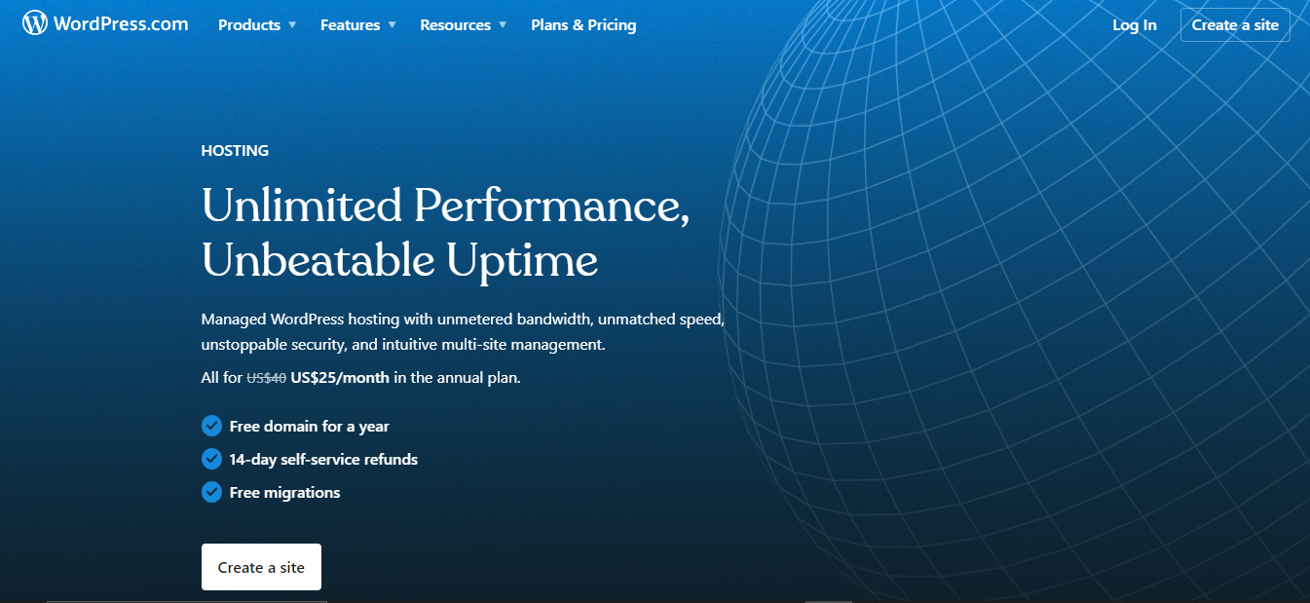

*Figure 10: Wordpress*

# Custom-Built Sites

When it comes to build websites, they are created from the ground up using coding languages such, as HTML, CSS, JavaScript and backend technologies. These websites are designed to meet needs in terms of design, functionality and branding. Developers have control over the structure, design and features of the website enabling them to create highly customized solutions. Custom-built sites can range from simple static websites to complex web applications. They require a deeper understanding of coding languages and development practices.

**Difference between Online Website Creation Tools and Custom-Built Sites**

|  |  |  |
| --- | --- | --- |
| Aspect | Online Website Creation Tools | Custom-Built Sites |
| Design Flexibility | Online tools allow users to tweak templates, yet remain constrained by the template's predefined structure and elements. This often limits the extent of customization and unique design possibilities. | Custom-built sites grant developers a remarkable level of creative freedom. They can craft bespoke designs that perfectly align with the brand's identity and project requirements. This enables a truly distinctive visual appeal and layout. |
| Performance | The performance of websites developed with online tools hinges on factors like the chosen hosting platform and the template's quality. However, the scope for granular performance optimization can be limited due to template constraints. | Custom-built sites place the reins of performance optimization squarely in the hands of developers. This control empowers them to fine-tune elements such as code efficiency, image compression, and caching strategies, resulting in optimized loading times and user experiences. |
| Functionality | Online platforms offer a selection of pre-defined features and functionalities that users can incorporate into their sites. However, these functionalities may have limited customization options beyond what the platform provides. | Custom-built sites shine in the realm of functionality. Developers have the freedom to engineer intricate and tailor-made functionalities that align perfectly with the website's specific goals and user needs. This allows for the creation of truly unique web experiences. |
| User Experience (UX) | User experience can be influenced by the template's constraints, potentially impacting the alignment between the intended user journey and the available design options. | Custom-built sites prioritize user experience by allowing developers to meticulously design user journeys, interactions, and visual elements from scratch. This results in seamless navigation, intuitive interactions, and enhanced user engagement. |
| User Interface (UI) | The design of the user interface within online tools adheres to the template's structure, potentially resulting in a website that looks similar to others using the same template. | Custom-built sites take UI design to a different level. Developers have the flexibility to create a unique visual identity that aligns perfectly with the brand. This encompasses tailored elements, layouts, and interactions that optimize user engagement and satisfaction. |

In Summary, the technologies utilized to develop, host, and manage the Gorkha Martial Arts website play a pivotal role in shaping its functionality, design, and accessibility. Proper DNS management, hardware-software relationships, web development technologies, SEO practices, and understanding front-end and back-end dynamics are critical for creating a successful and impactful website. The decision between using online website creation tools or custom-built solutions depends on the specific needs and objectives of Gorkha Martial Arts. It's crucial to strike a balance between ease of use and a tailored user experience to achieve the desired online presence.

# Conclusion

In conclusion, this report has provided a thorough exploration of various facets of web development, from the critical role of DNS servers to the nuanced choices between custom-built websites and online website creation platforms. It emphasizes the importance of technology and strategy in shaping a successful online presence for businesses like Gorkha Martial Arts. Throughout this report, we've seen how each decision, whether related to hardware, software, SEO, or design, can significantly impact the overall effectiveness of a website. These considerations are essential in delivering a tailored, high-quality web solution that aligns with an organization's goals and resonates with its audience. Ultimately, the success of web development hinges on the thoughtful integration of these technologies and techniques to create a dynamic, user-friendly, and impactful online presence.

# Client Requirements

1. The site should promote Gorkha Martial Arts effectively, highlighting services and facilities.
2. Martial arts class info must be clear and accessible.
3. Membership costs and options should be well-presented.
4. User accounts for membership management, forums, and social integration are needed.
5. Instructor profiles and class timetable must be easily accessible.

# User Requirements

1. Easy access to detailed martial arts class info is expected.
2. Clear membership breakdowns with costs are essential.
3. Smooth account creation, login, and management are required.
4. Interactive features like forums and social integration are desired.
5. Instructor profiles and a clear class timetable are crucial.

# Functional Requirements

1. Engaging homepage, introducing Gorkha Martial Arts.
2. Well-structured martial arts class details.
3. Clear pricing table with membership info.
4. Seamless account handling, forums, and social integration.
5. Accessible instructor profiles and clear class timetable.

# Non-Functional Requirements

1. Load time within 3 seconds for a smooth experience.
2. Compliance with WCAG 2.0 guidelines for accessibility.
3. Secure data handling with encryption and storage.
4. Compatibility with major browsers (Chrome, Firefox, Safari, Edge).
5. Best practices for design, hosting, and code quality.

# User Acceptance Criteria

1. Quick access to detailed martial arts info is achievable.
2. Clear membership details, costs, and features are evident.
3. Easy account creation, login, and management.
4. Meaningful engagement via forums and social integration.
5. Comprehensive instructor profiles and accessible timetable.

# Wireframe

## Home page Before Login Wireframe

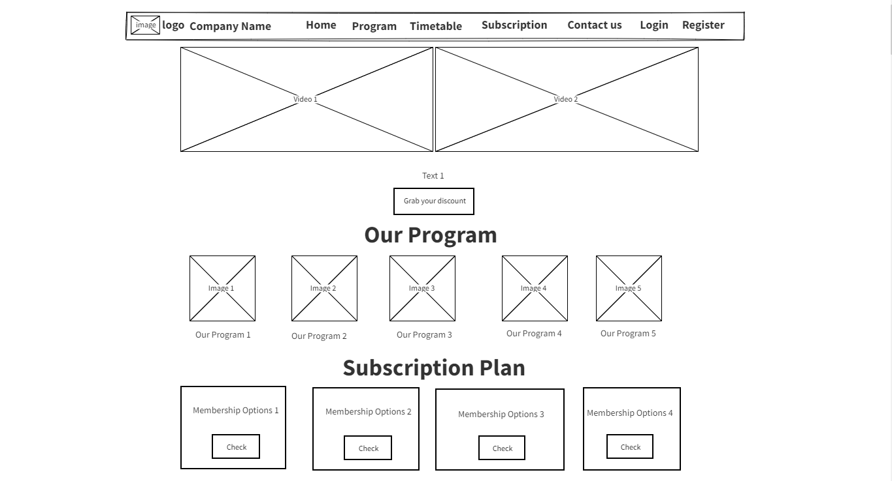

*Figure 11: Wireframe Home page part 1*

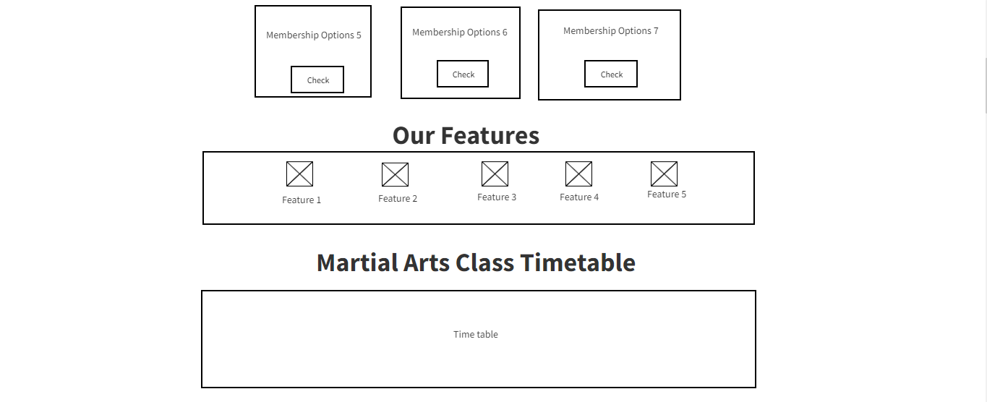

*Figure 12: Home page wireframe part 2*

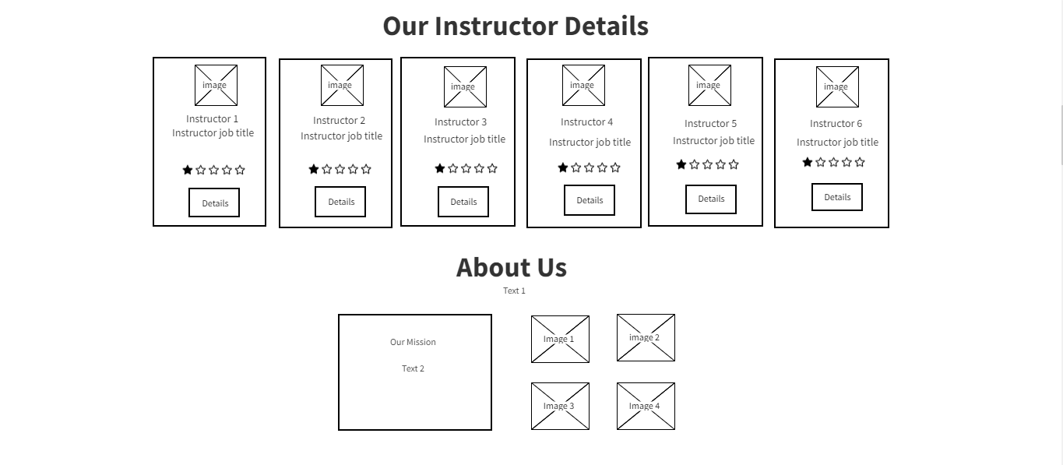

*Figure 13: Home page wireframe part 3*

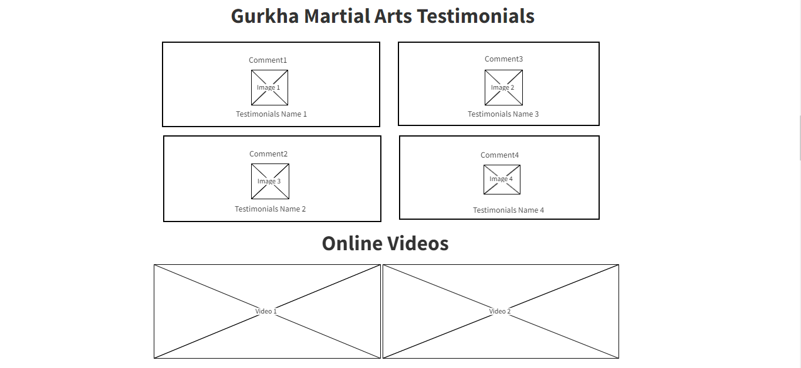

*Figure 14: Home page wireframe part 4*

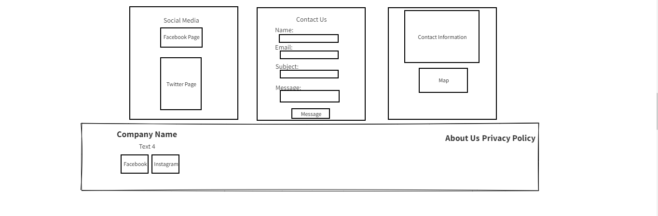

*Figure 15: Home page wireframe part 5*

## User Register wireframe:

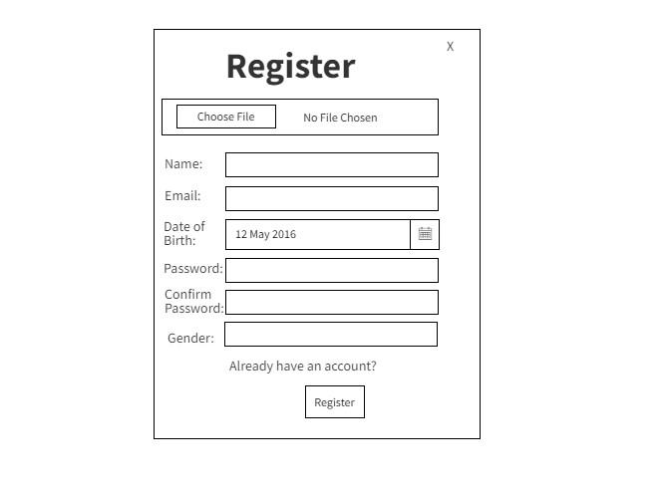

*Figure 16: User Register wireframe*

## User Login wireframe:

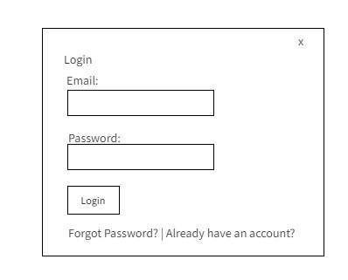

*Figure 17: User Login Wireframe*

## Home Page after login User wireframe:

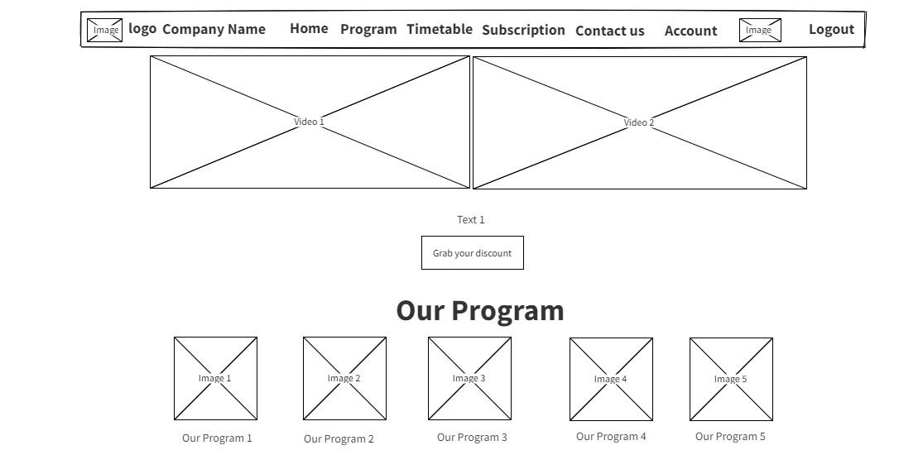

*Figure 18: Home page wireframe after Login part 1*

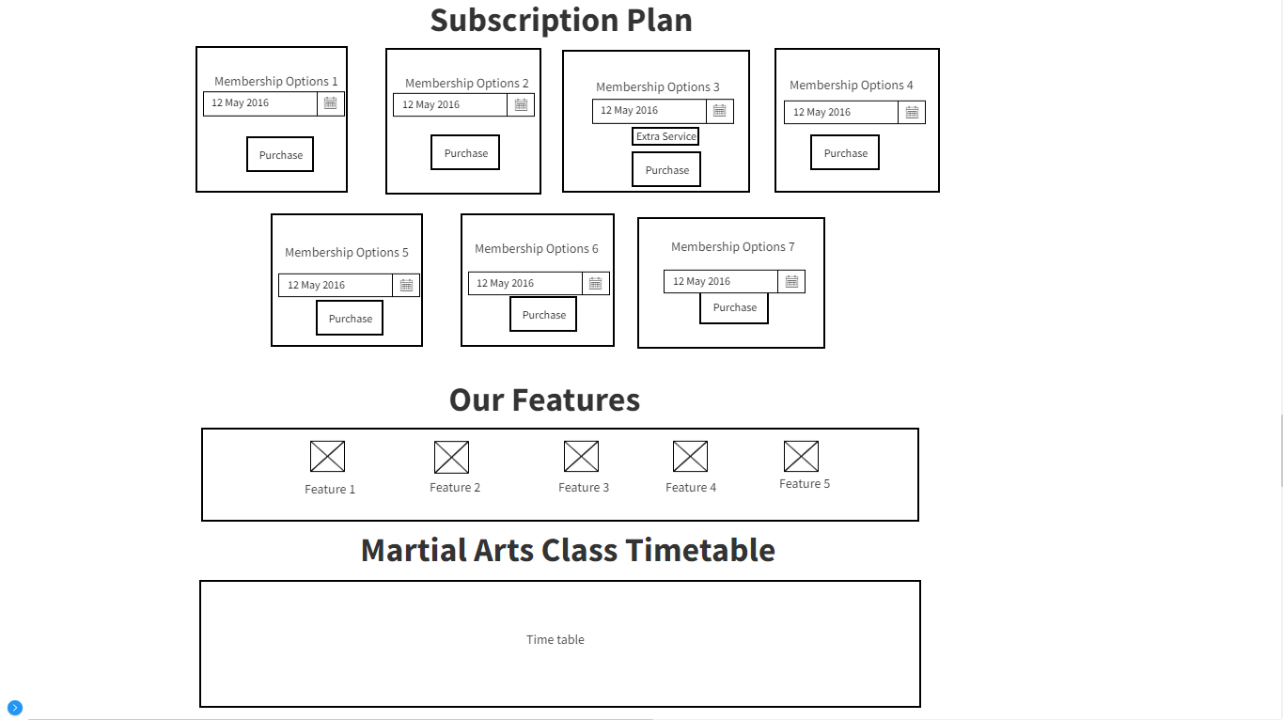

*Figure 19: Home page wireframe after login part 2*

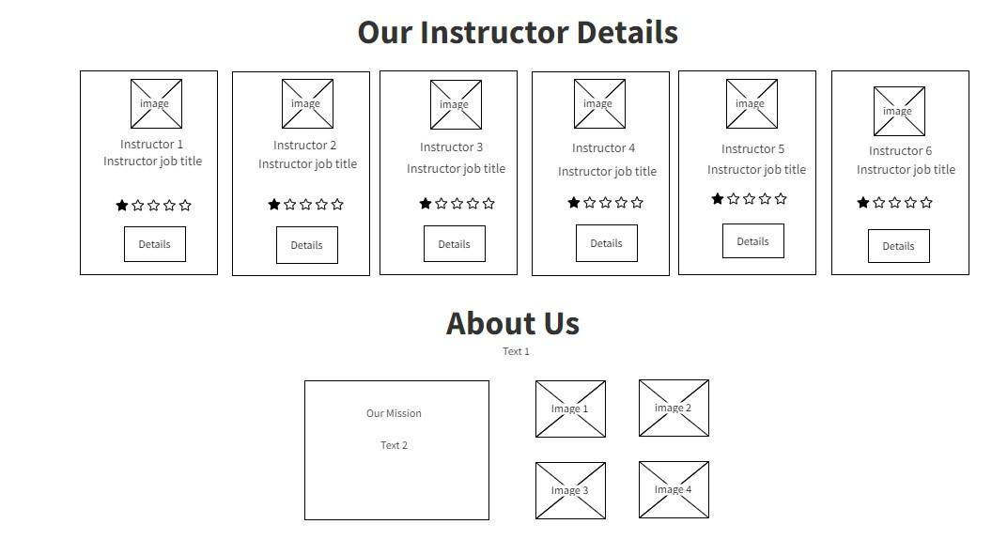

*Figure 20: Home page after login part 3*

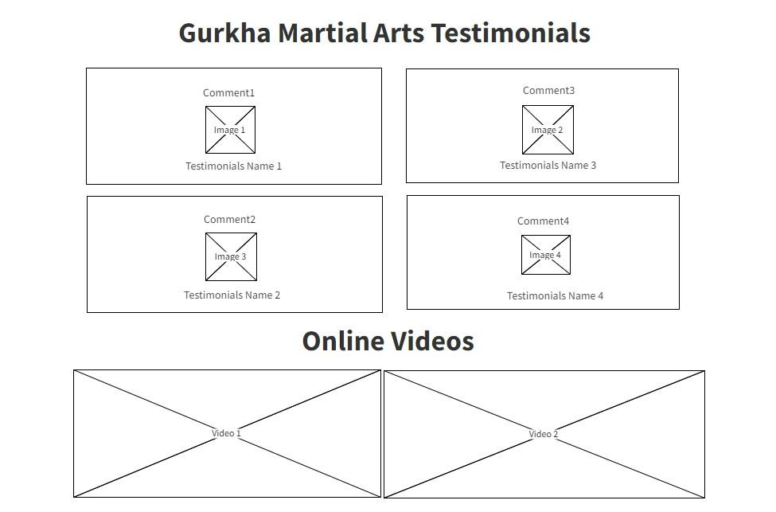

*Figure 21: Home Page After login part 4*

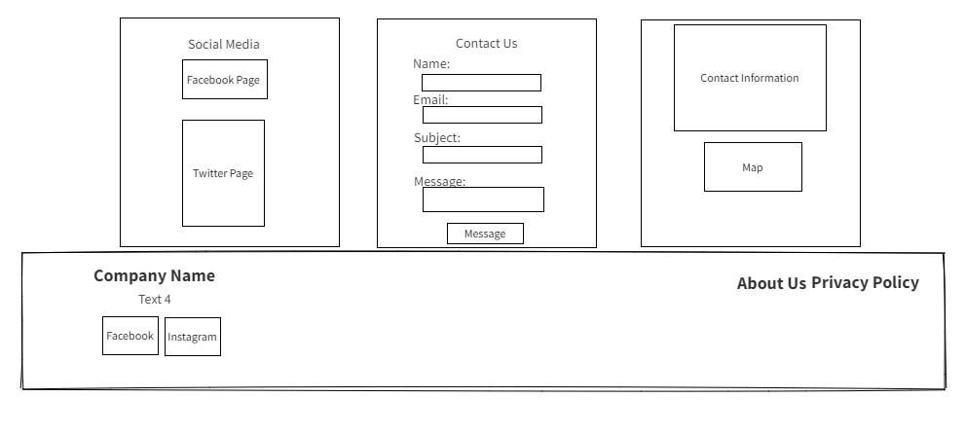

*Figure 22: Home page after login part 5*

## Account (User Profile) wireframe:

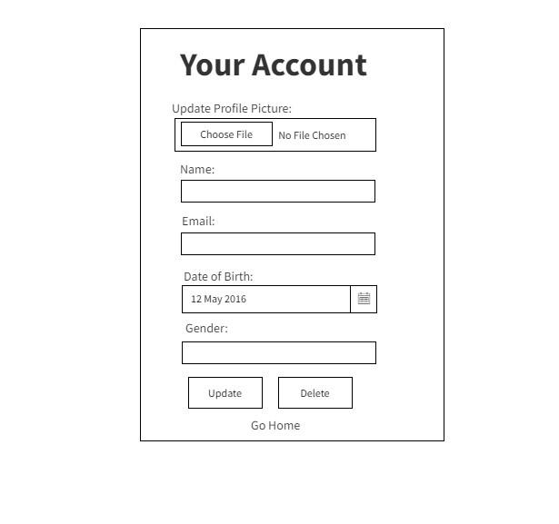

*Figure 23: Account Profile wireframe*

# Interface Design

## Interface Design of Home Page Before Login



*Figure 24: Menu bar Before Login in website*



*Figure 25: Program in Website*

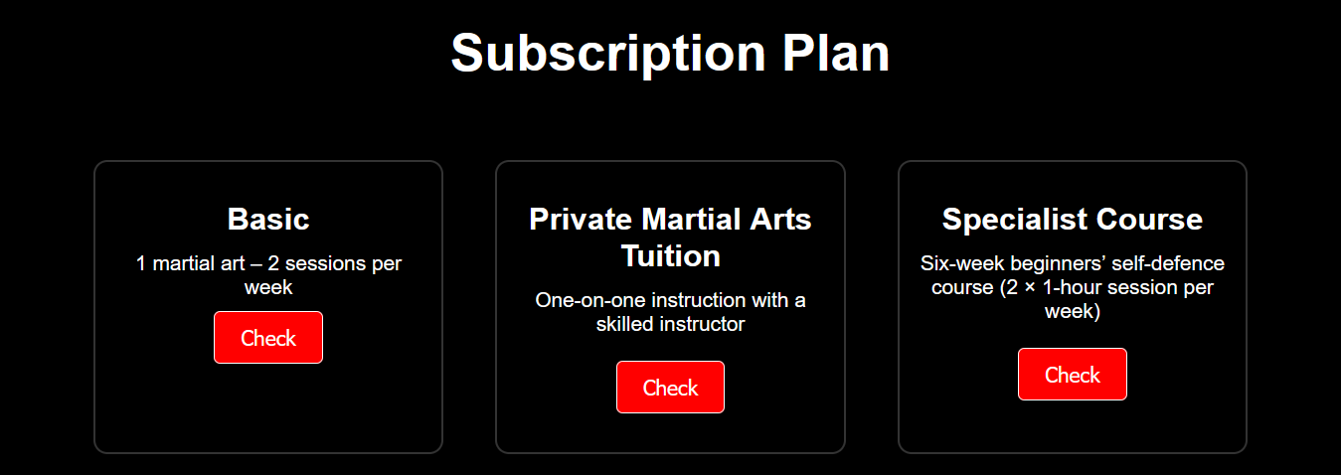

*Figure 26: Subscription Panel Before Login part 1*

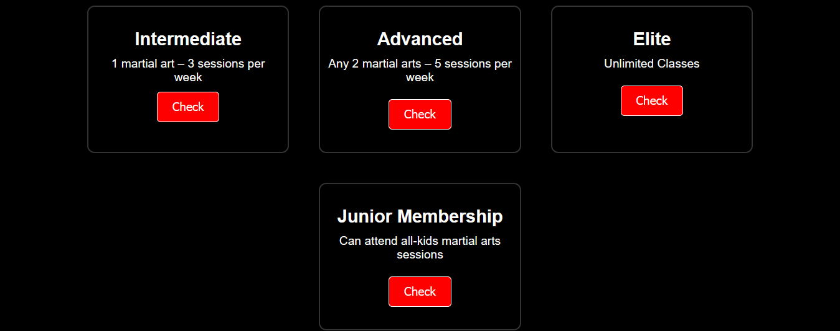

*Figure 27: Subscription Panel Before Login part 2*

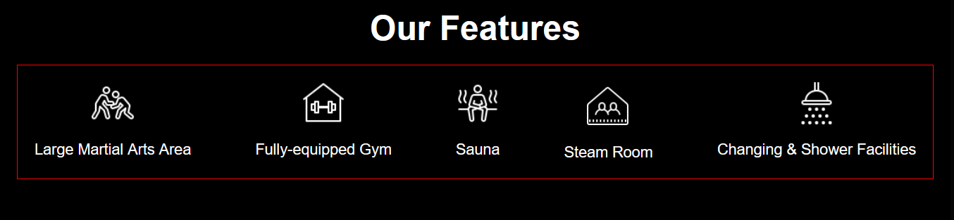

*Figure 28: Feature of Website*

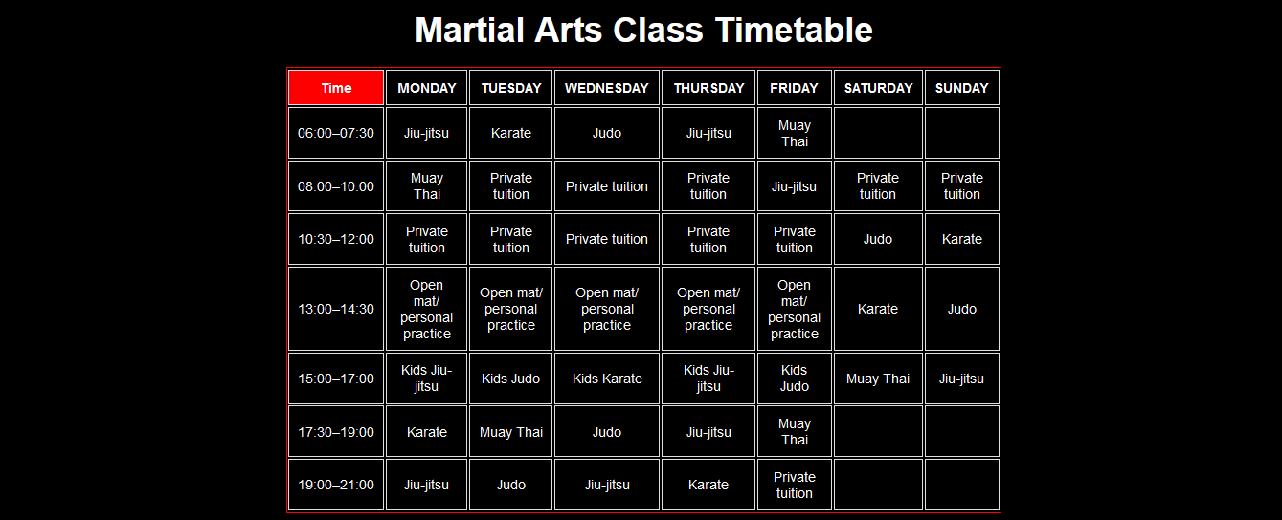

*Figure 29: Class Timetable in Website*

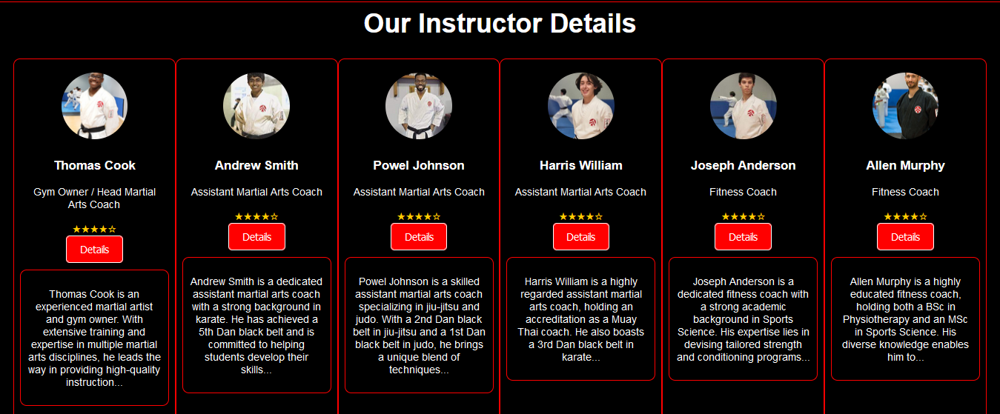

*Figure 30: Instructor Details in Website*

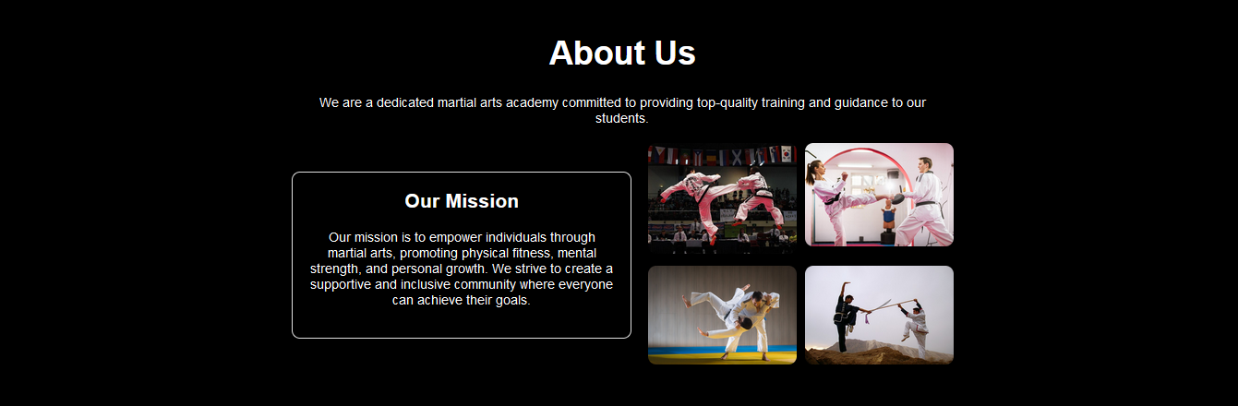

*Figure 31: About Us Page in Website*



*Figure 32: Testimonials in Website*

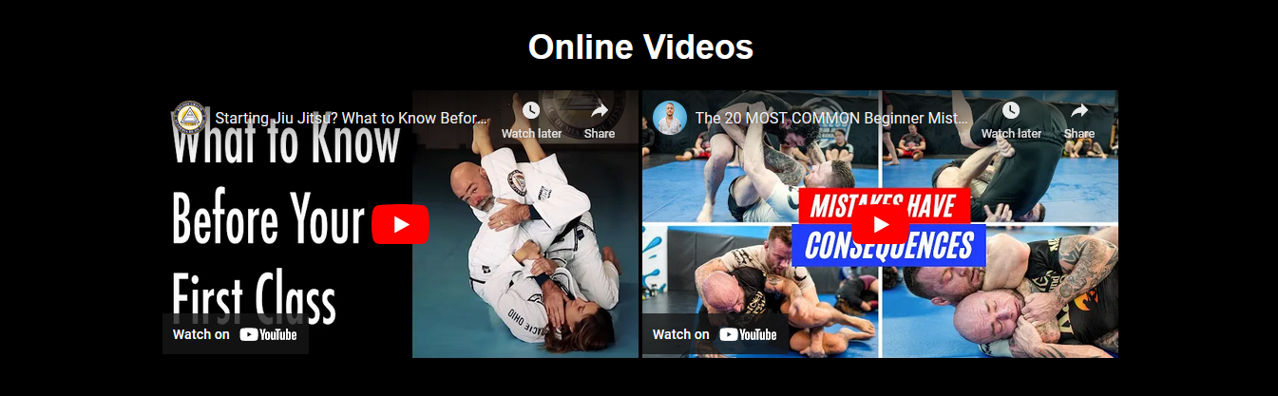

*Figure 33: Online Video in Website*

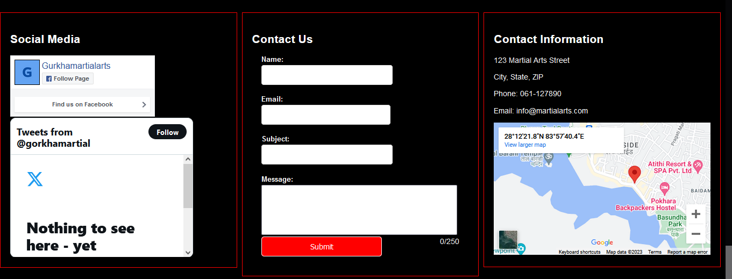

*Figure 34: Contact Us and Social Integration in website*



*Figure 35: Footer in Website*

## User Register Interface Design:

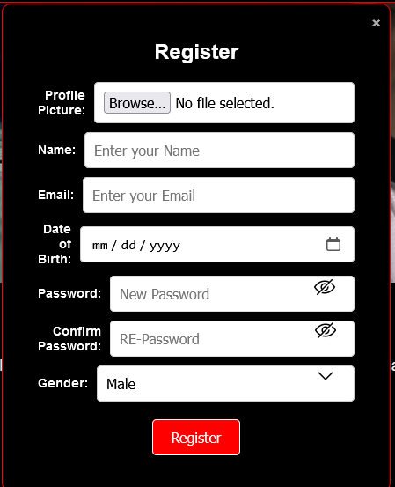

*Figure 36: Register in Website*

## User Login Interface Design:

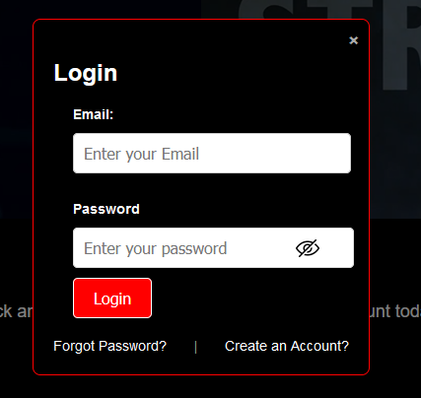

*Figure 37: Login in Website*

## Menubar After User Login Interface Design

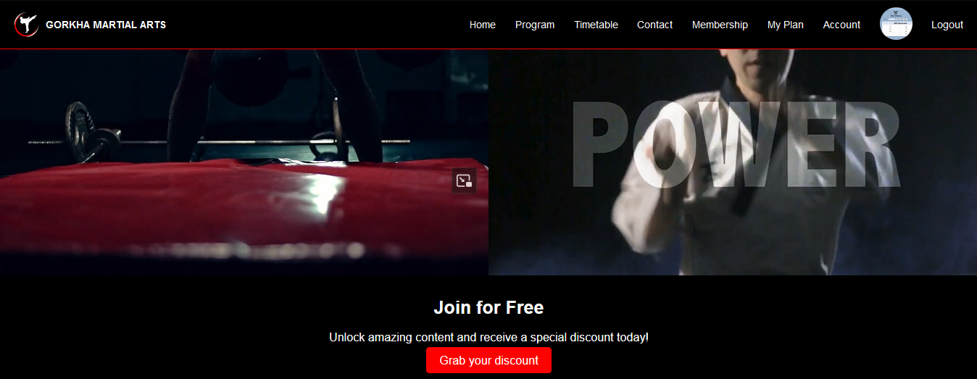

*Figure 38: Menubar After Login in Website*

## Subscription Plan After Login Interface Design

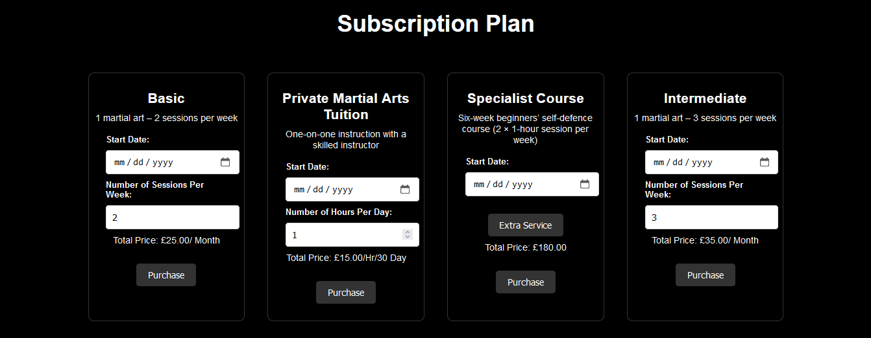

*Figure 39: Subscription Plan in website part 1*



*Figure 40: Subscription Plan in website part 2*

## My Plan Interface Design



*Figure 41: My Plan In website*

## Forget password Interface Design

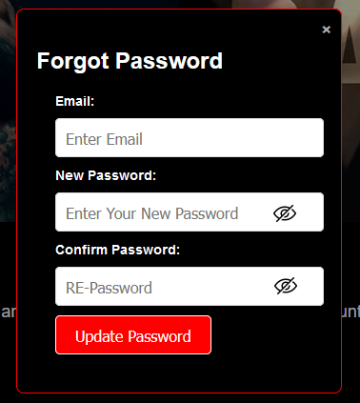

*Figure 42: Forget Password in Website*

## Account Profile Interface Design

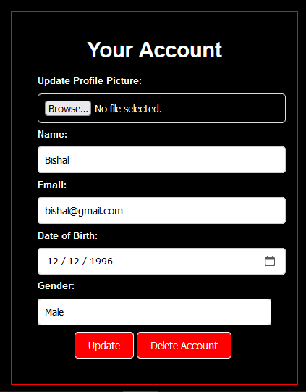

*Figure 43: Login Account Update Image*

# Networking Considerations

When creating the website for Gorkha Martial Arts, several networking considerations need to be taken into account to ensure smooth functionality, accessibility, and security for both the users and the administrators.

## Domain Name and DNS Configuration

Choose a relevant and easy to remember domain name for the website, possibly related to the gym's name. Configure the DNS settings accurately to establish a connection, between the domain name and the IP address. This will guarantee that the website can be accessed using its designated domain name.

## SSL Certificate and HTTPS

Implement an SSL certificate to enable HTTPS for the website. This will guarantee that data transmission, between user’s browsers and the web server is secure. Google also takes into account the use of HTTPS when determining a website ranking, which helps improve its SEO.

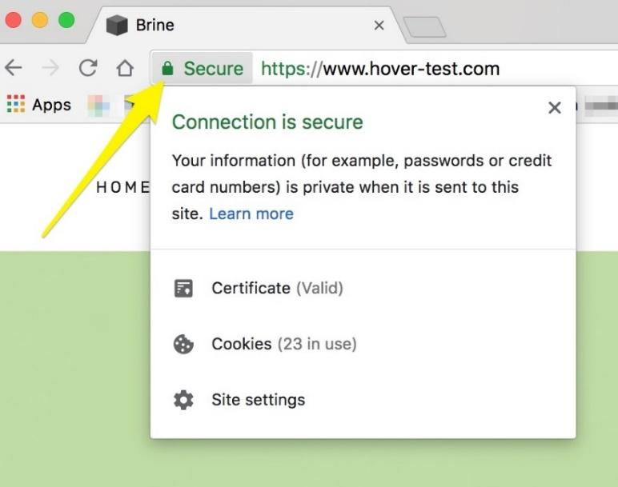

*Figure 44: Connection Secure SSL HTTPS*

## Content Delivery Network (CDN)

It is a tool for distributing website content across servers located in parts of the world. This helps reduce delays and improves the loading speed of website pages for users accessing the site, from regions of world.

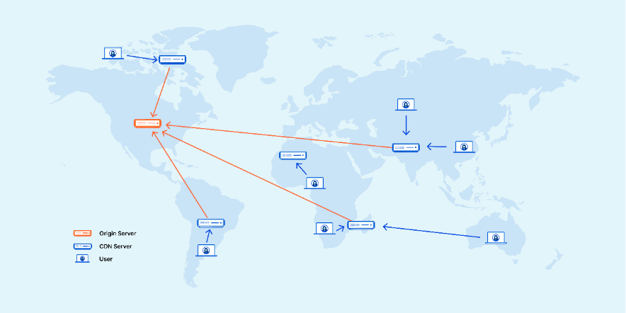

*Figure 45: CDN Figure*

## Network Security

To maintain network security, it is crucial to establish a firewall and implement security measures. These precautions are necessary to safeguard against threats, like Distributed Denial of Service (DDoS) attacks, malware infections and unauthorized access. It is also important to update and patch the servers operating system and software as a means to maintain its security.

## Database Connectivity

If the website uses a database for user accounts, class schedules, and other information, ensure secure database connectivity with appropriate user authentication and authorization mechanisms.

# Hosting Considerations

Selecting the hosting solution is importance to ensure the optimal performance, availability and scalability for a website. Given Shangri-la's expertise, the following hosting considerations should be taken into account:

## Hosting Type

When it comes to choosing the hosting type for website, we should take into account factors such as the anticipated traffic and specific requirements. There are several types of hosting services available, each with its own characteristics. These include shared hosting, virtual private servers (VPS), dedicated servers, and cloud hosting. For Gorkha Martial Arts, a dedicated server or VPS might be suitable to ensure better performance and control.

## Server Location

Select a server location that is geographically closer to the target audience. This reduces latency and improves page loading speed, enhancing the user experience.

## Server Performance and Resources

Ensure that the hosting provider provides resources such as CPU, RAM and storage to meet the requirements of website. This is especially important, during periods when multiple users might be accessing the site at the time.

## Scalability

Consider future growth when choosing a hosting plan. The gym's website may attract more visitors over time, so the hosting solution should allow for easy scalability to accommodate increased traffic and resource demands.

## Backup and Recovery

To avoid losing data in the event of server failures or unexpected incidents it is important to create backups of your websites data and configurations. A robust backup and recovery strategy is essential for maintaining business continuity.

## Technical Support

Choose a hosting company that provides reliable technical support. In case of any issues or emergencies, having access to responsive support can help minimize downtime and disruptions.

## Content Management System Compatibility

Ensure that the hosting environment is compatible with the selected content management system (CMS) or website-building platform to prevent from any compatibility problems.

## Uptime and Reliability

Choose a hosting provider that has a strong history of keeping websites online and reliable. This will ensure that website is available to users without interruptions.

By considering these networking and hosting considerations, we can ensure that the Gorkha Martial Arts website is not only visually appealing and functional but also secure, fast, and accessible to users.

# Security features that could be implemented in the Gorkha Martial Arts

## SSL/TLS Encryption

By implementing SSL/TLS encryption we can ensure that the data being transmitted between user’s web browsers and the website server is securely encrypted. This prevents eavesdropping and data interception, safeguarding sensitive information like login credentials and personal details.

## User Authentication Security

By implementing an authentication system with multi factor authentication (MFA) enhances the security measures. Users need to provide forms of verification to access their accounts and they can effectively minimize the risk of unauthorized access.

## Regular Software Updates

It is important to maintain all the software up-to-date, including CMS, plugins and frameworks. Security patches are issued to tackle vulnerabilities. Regular updates minimize the risk of exploiting outdated software.

## Web Application Firewall

A Web Application Firewall serves as a tool, for web applications which ensure their security by filtering and monitoring incoming traffic to prevent from cyber threats. It works by identifying and blocking known attack methods, like SQL injection and cross site scripting (XSS) making web-based defenses stronger.

## Regular Backups

Regularly backing up the website's data and files is essential for disaster recovery. If there is a security breach or loss of data having backups allows you to restore the website back, to a previous version which is safe and secure.

# Accessibility and inclusivity guidelines implementation

It is essential to incorporate accessibility and inclusivity guidelines in order to make sure that the Gorkha Martial Arts website can be easily used by disabilities user. These guidelines will be applied to the website as follows:

## Semantic HTML Markup

The websites design will include HTML tags such, as headings, lists and paragraphs to ensure that the content is organized in a manner. This is important for screen readers and assistive technologies as it helps users who have disabilities to navigate the site.

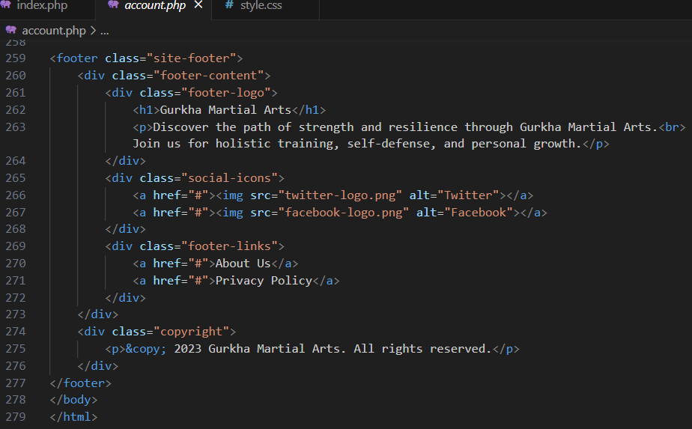

*Figure 46: HTML MARKUP*

## Descriptive Alt Text for Images

All images, whether showcasing martial arts or facilities, will have informative alt text. This empowers visually impaired users to understand the content conveyed by images through screen readers.

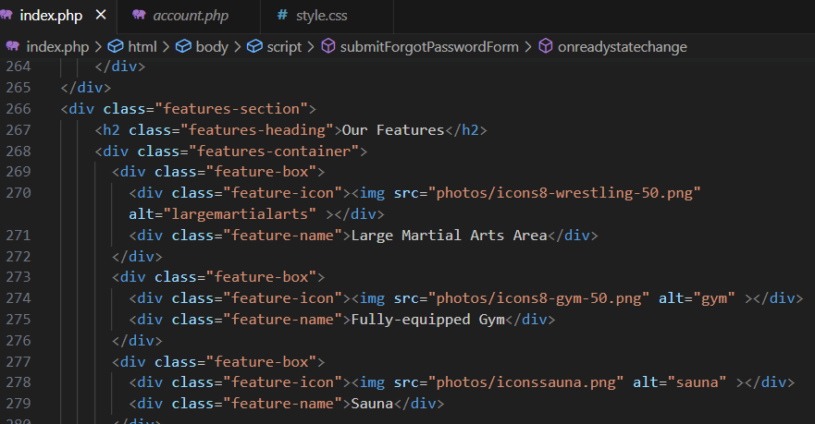

*Figure 47: Image Alt Text*

## Keyboard Navigation and Focus States

The website will be designed for keyboard navigation, allowing users to interact without a mouse. Clear focus states will highlight interactive elements, aiding users in tracking their position and actions on the site.

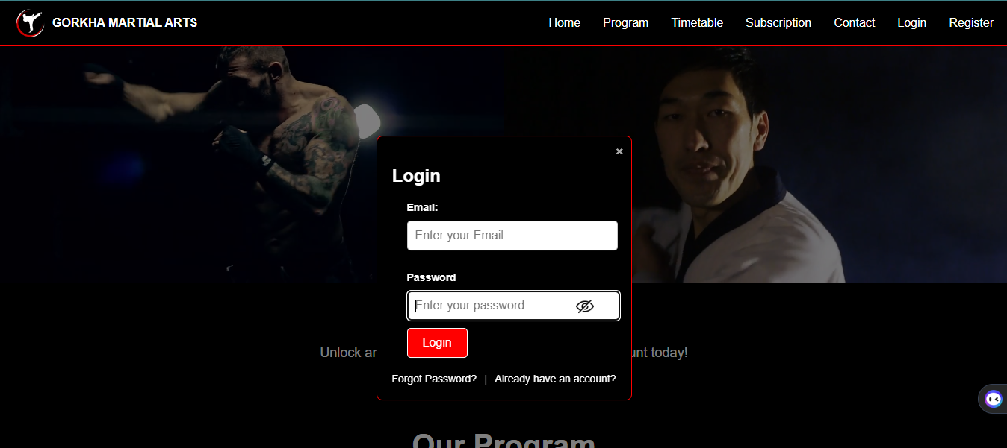

*Figure 48: Keyboard Navigation*

## Color Contrast

Color contrast will maintain the colors of text and background to ensure more readability for users which has color blindness. The chosen color palette will adhere to accessibility standards.

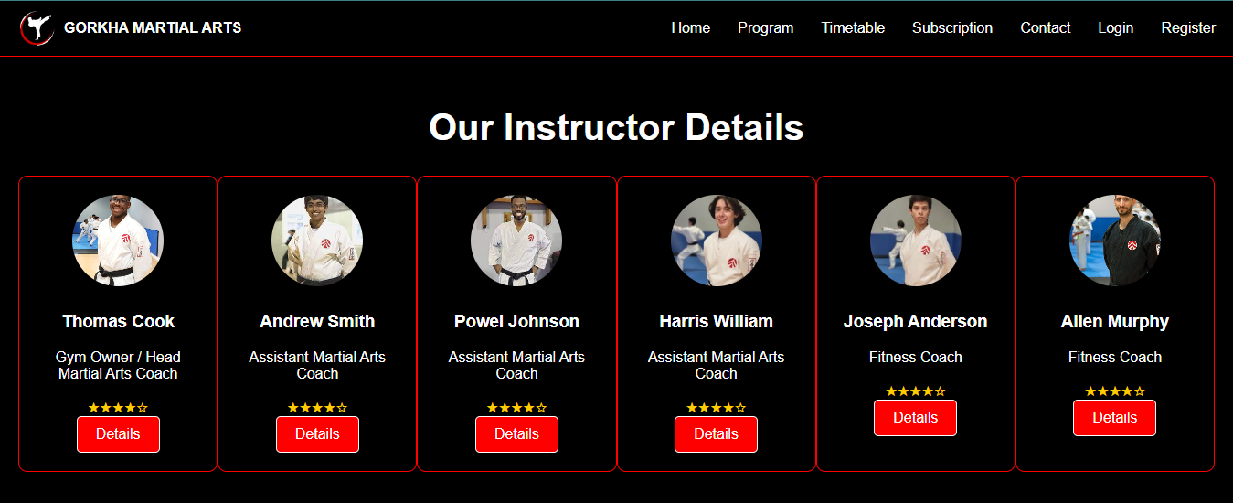

*Figure 49: Color Constraint*

## Responsive and Flexible Design

By incorporating design principles, the website will seamlessly adapt to screen sizes and devices. This ensures that users, with abilities and assistive technologies can enjoy a browsing experience.

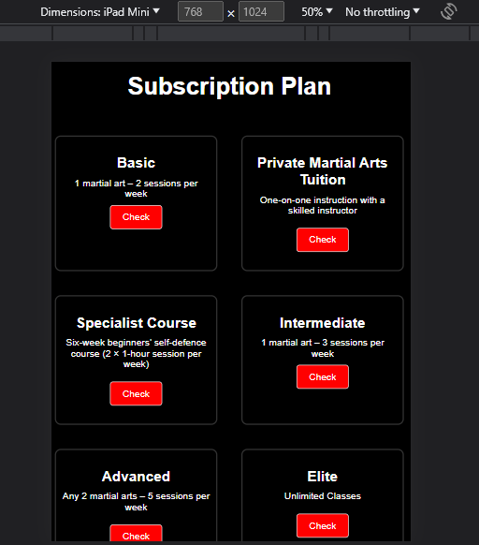

*Figure 50: Responsive Design*

## Accessible Forms and Error Handling

Forms, such as account creation and contact forms, will be designed with accessible labels and placeholders. Clear error messages will guide users through the form-filling process, benefiting those with cognitive and motor impairments.

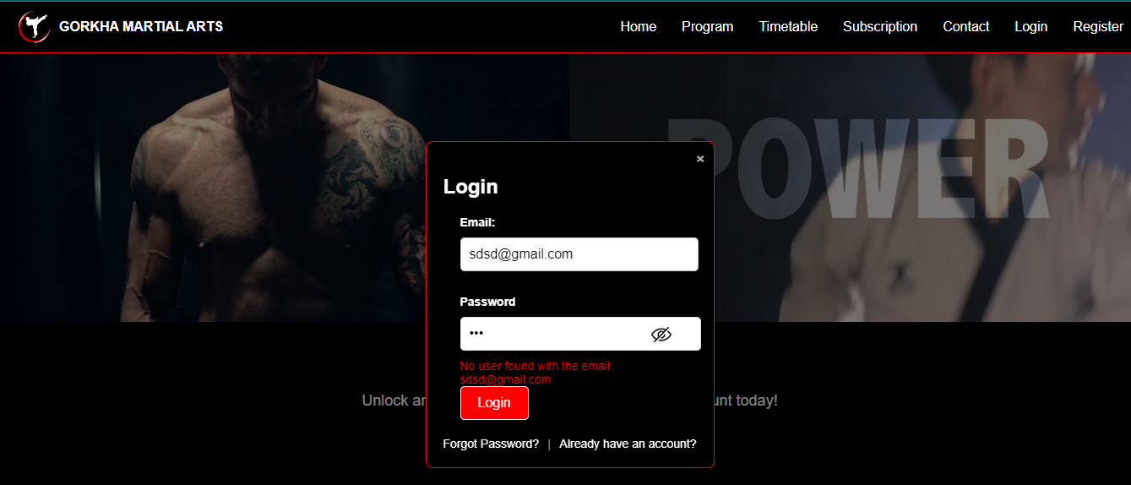

*Figure 51Error Handling Image*

By following these accessibility and inclusivity guidelines, the Gorkha Martial Arts website will create a welcoming and inclusive online environment, ensuring that all users can access and interact with the content seamlessly.

# Test Plan

## Registration and Login Functionality

|  |  |  |  |
| --- | --- | --- | --- |
| **Test Description** | **Expected Result** | **Final Result** | **Successful/Unsuccessful** |
| User can enter valid credentials | User is logged in successfully | User logged in | Successful |
| User enters invalid credentials | User receives an error message | Error message displayed | Successful |
| User provides valid registration | User account is created and confirmation shown | Account created | Successful |
| User provides incomplete information | User receives error messages for missing info | Errors displayed | Successful |

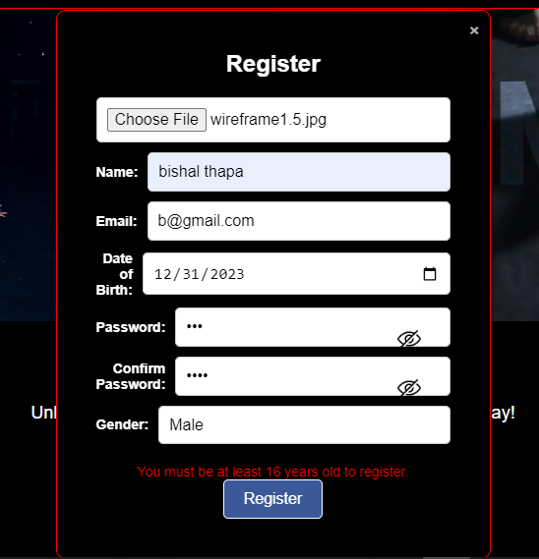

*Figure 52: Registration Testing Plan*

## Account Update

|  |  |  |  |
| --- | --- | --- | --- |
| **Test Description** | **Expected Result** | **Final Result** | **Successful/Unsuccessful** |
| User uploads profile picture | Picture is uploaded successfully | Picture uploaded | Successful |
| User change Name, Email, Date of Birth | Account is updated successfully | Account updated | Successful |

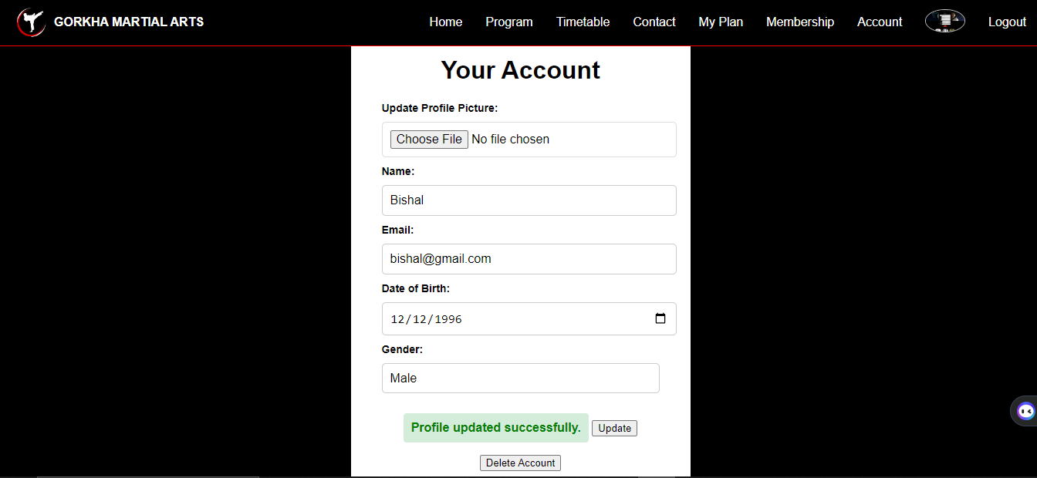

*Figure 53: Account Update Testing Plan*

## Contact Us Form

|  |  |  |  |  |  |
| --- | --- | --- | --- | --- | --- |
| **Test Description** | | **Expected Result** | | **Final Result** | **Successful/Unsuccessful** |
| User fills out valid information | User receives a confirmation message | | Confirmation received | | Successful |
| User leaves required fields empty | User receives error messages for missing info | | Errors displayed | | Successful |

## Membership Options and Prices

|  |  |  |  |  |
| --- | --- | --- | --- | --- |
| **Test Description** | **Expected Result** | | **Final Result** | **Successful/Unsuccessful** |
| Elite membership selected | Correct price and description are shown | | Details correct | Successful |
| Junior membership selected | Details of junior membership are shown | | Details displayed | Successful |
| Intermediate membership selected | | Details of intermediate membership are shown | Details displayed | Successful |
| Advanced membership selected | | Membership details and price are displayed | Details shown | Successful |
| Private martial arts tuition selected | | Correct price and description are shown | Details correct | Successful |
| Six-week beginners self-defense selected | | Details of beginner self-defense membership are shown | Details displayed | Successful |

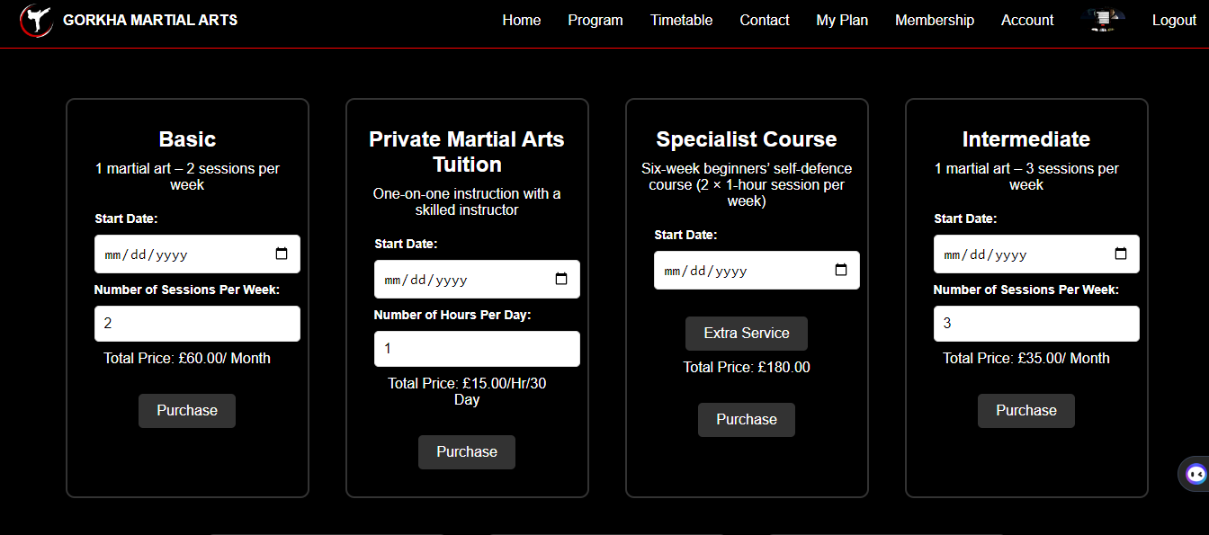

*Figure 54: Membership Price Display Testing Plan*

## Membership Purchase

|  |  |  |  |
| --- | --- | --- | --- |
| **Test Description** | **Expected Result** | **Final Result** | **Successful/Unsuccessful** |
| Package purchase more than twice | User receives a notification about no availability already purchase | Notification received | Successful |



*Figure 55: Membership Purchase Testing*

## Website Responsiveness

|  |  |  |  |
| --- | --- | --- | --- |
| **Test Description** | **Expected Result** | **Final Result** | **Successful/Unsuccessful** |
| Website is accessed on mobile | Content is responsive and easily readable | Content responsive | Successful |

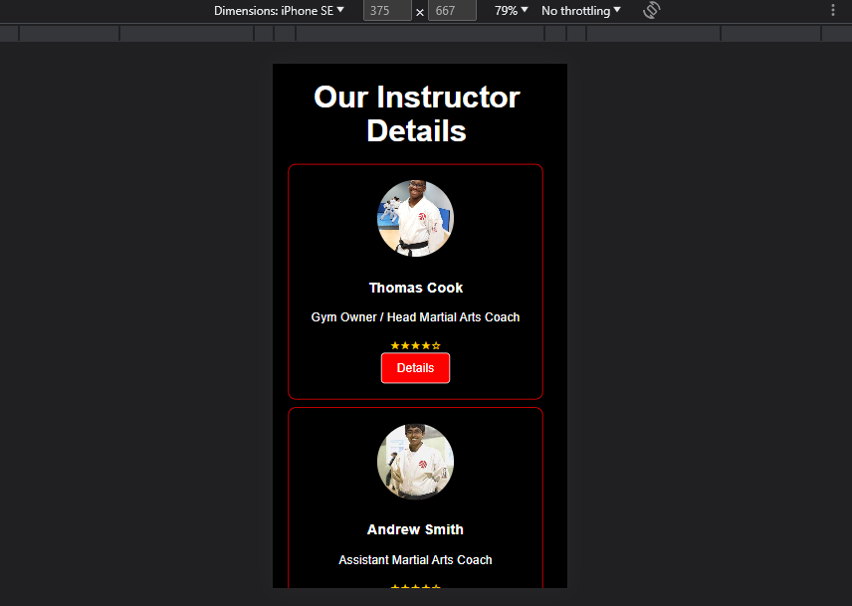

*Figure 56: Responsive Testing Plan*

# Explanation of the web design principles, standards and guidelines

## Web Design Principles

The website follows fundamental design principles that include Visual Hierarchy, where content is strategically organized to aid navigation and prioritize essential information. Contrast is employed to enhance readability through distinct color choices and font sizes. Consistency is maintained across the site, ensuring uniform styles that contribute to a cohesive visual identity. The principle of "Accessibility" is paramount, guaranteeing that the website is usable by all users, including those with disabilities, achieved through alt text for images and proper HTML structure.

## Web Design Standards

The website adheres to industry best practices and standards, utilizing HTML5, CSS3, and JavaScript for modern web development. HTML5 provides a semantic structure that enhances both search engine optimization and accessibility. CSS3 is employed to establish consistent styles, manage layout, and achieve responsiveness through the Box Model and media queries. JavaScript enhances user interactivity while adhering to the ECMAScript standards for compatibility and maintainability.

## Web Design Guidelines

The design guidelines encompass various aspects of the website's presentation and user experience. Typography guidelines prioritize legibility, employing easy-to-read fonts with appropriate sizing for different screens. Color guidelines ensure a harmonious and impactful color scheme, maintaining sufficient contrast for optimal readability. Layout guidelines dictate the arrangement of elements, relying on a grid-based structure to facilitate logical content organization. Navigation guidelines contribute to an intuitive user experience with clear and descriptive menus. Additionally, responsive design guidelines ensure that the website functions seamlessly on diverse devices, adapting elements to ensure a consistent and enjoyable user experience (Tanner, 1997).

# Executive Summary

The evaluative report on the Gorkha Martial Arts website design and development reveals a successful project that effectively meets the client's needs. The report justifies the selection of management services, tools, and software employed in the website's creation, emphasizing their role in efficient project management. It evaluates the design and development process, highlighting alignment with the original design document's core objectives. The report also discusses specific technical challenges faced during development and the strategies employed to overcome them, resulting in a technically robust website. Furthermore, the Test Plan results and overall website success underscore its functionality and user satisfaction. Finally, the report provides recommendations for further improvements based on client feedback and testing outcomes, ensuring the website's continued growth and alignment with the client's objectives.

# Introduction

This evaluative report delves into the design and development of the Gorkha Martial Arts website, offering a comprehensive analysis of the processes, tools, and outcomes. The creation of the Gorkha Martial Arts website involved a strategic selection of management services, tools, and software, which will be justified in the subsequent sections. We will evaluate how well the final website aligns with the initial design document, identify specific technical challenges encountered during development, and assess the results of the implemented Test Plan. Additionally, we will provide recommendations for further improvements to enhance the website's performance and user engagement, taking into account client feedback and testing outcomes. This report aims to provide a thorough assessment of the project's success and areas for potential growth in the online presence of Gorkha Martial Arts.

# A justification of the implementation of the multi-page website decisions against the planned design decisions.

Our created website closely aligns with the planned design decisions, prioritizing user-friendliness, accessibility, SEO optimization, and instructor credibility. The user-friendly navigation menu, in line with our initial plan, ensures an intuitive layout for easy access to essential information about martial arts classes, pricing, and instructor profiles, thereby enhancing the overall user experience. One distinct addition is the dedicated forum section, which was absent in the initial plan but introduced to foster community and social interaction. This addition significantly elevates engagement and enhances the online community (Sundaram, 2003).

Additionally, both the plan and implementation share a commitment to a mobile-friendly design, emphasizing accessibility across devices and screen sizes. This consistency ensures user-friendliness regardless of the device used. Furthermore, both approaches include a comprehensive SEO-focused content strategy, aiming to improve search engine visibility, increase organic traffic, and boost the gym's online presence.

Instructor profiles, a planned design element, were executed with detailed profiles showcasing instructors' qualifications, martial arts specialties, and high-quality photos, thereby building trust with potential members. Notably, the implementation and planned design both incorporate HTML5, CSS3, and JavaScript for front-end development, creating responsive and user-friendly interfaces.

Another alignment is the strategic use of PHP on the backend, mirroring the planned decision to enable real-time data processing and efficient communication between the user interface and the server. This approach maintains the seamless interaction envisioned in the design. However, one significant difference was the choice of the web hosting operating system. While the original plan considered both Windows Server and Ubuntu, the implementation focused solely on Ubuntu Server. This decision was driven by Ubuntu's stability, security, and extensive support from its open-source community, aligning well with the project's long-term goals (Tomaszewski, 2020).

In conclusion, our created website closely adheres to the planned design decisions, with shared focuses on user-friendliness, accessibility, SEO optimization, and instructor credibility. The addition of the forum enhances community engagement, while the alignment in technology choices ensures a responsive and seamless user experience. The choice of Ubuntu Server as the hosting OS optimizes long-term stability and security. These thoughtful considerations collectively contribute to an effective online platform for Gorkha Martial Arts.

# An implementation of the test plan against the final developed multi-page website

As a junior developer responsible for the Gorkha Martial Arts website, I executed the developed test plan to validate the functionality and user experience of the multi-page website according to the planned design.

In terms of registration and login functionality, I confirmed that users could successfully log in using valid credentials and received appropriate error messages for invalid inputs. Similarly, during registration, I ensured that new accounts were created and confirmation messages were displayed as intended. The system effectively handled incomplete user information by triggering the expected error messages.

I proceeded to test the account update feature, including actions like uploading profile pictures and modifying account details such as name, email, and date of birth. These actions were executed successfully, and the website accurately updated user profiles.

Testing the contact us form involved verifying that valid information generated confirmation messages, while leaving required fields empty prompted the anticipated error messages. This ensured the form's proper functioning and error handling.

During the assessment of membership options and prices, I confirmed that all tested membership categories—Elite, Junior, Intermediate, Advanced, Private Martial Arts Tuition, and the Six-week Beginners Self-Defense course—correctly displayed the relevant information and associated costs.

For membership purchases, I examined scenarios where users attempted to buy packages more than twice, confirming that the website appropriately communicated package unavailability after a purchase, as intended.

Lastly, I evaluated the website's responsiveness by accessing it on mobile devices. The content's responsiveness and readability were validated, demonstrating the successful implementation of a responsive design that adapts well to various screen sizes.

In summary, my implementation of the test plan against the final developed multi-page website for Gorkha Martial Arts showcased successful alignment with the expected outcomes. Thorough testing provided confidence in the website's functionality, user-friendliness, and adherence to the planned design decisions, ensuring a seamless user experience and effective promotion of the martial arts gym's offerings.

# Quality Assurance and Quality Assurance Process

Quality assurance (QA) is a systematic process that ensures products or services meet specified standards and satisfy customer requirements. In the context of software development or any other production process, QA focuses on preventing defects and identifying areas for improvement throughout the entire lifecycle. It involves a set of activities and methodologies designed to maintain and enhance the quality of the final output, providing confidence that the product or service will meet expectations.

The Quality Assurance process typically includes activities such as defining quality standards, establishing processes and procedures, conducting audits, and implementing corrective measures. It aims to prevent issues rather than just detecting and fixing them after production. QA is an integral part of the overall quality management system, emphasizing continuous improvement and adherence to predefined standards. By implementing a robust Quality Assurance process, organizations can enhance product reliability, customer satisfaction, and overall efficiency in delivering high-quality outcomes.

# QA implemented during the design and development stages of the multi-page website

The Quality Assurance (QA) process played a vital and essential role in making sure the Gorkha Martial Arts website worked well. Quality assurance made sure to incorporate this process from the start to ensure that the website is user friendly visually appealing and functions smoothly.

When the design was being planned, the QA process was involved in checking the design thoroughly. This meant not only looking at how the website looked but also how people would use it and if it worked well for everyone. The quality assurance team and the designers collaborated closely each other to identify and resolve any issues, with the design or user experience of the website (Henderi, 2020).

As the website was being built, the QA process was closely connected with the coding and making things work. They tested different parts of the website like signing up, logging in, updating accounts, and membership options. The quality assurance team put in a lot of effort to identify and resolve any errors or problems that arose. Additionally, they ensured that the website maintained an appearance and functionality, across devices and web browsers. They were really careful about keeping people's information safe and making sure the website couldn't be easily attacked.

From the start of designing to building, the QA process was always paying attention, quickly dealing with any problems that came up. They checked the website in different web browsers and made sure people's information was kept safe.

The findings from the comprehensive Quality Assurance (QA) process implementation during the design and development stages provide valuable insights into various critical aspects of the Gorkha Martial Arts website. Documentation played a crucial role as the QA team maintained meticulous documentation throughout the process, ensuring a transparent record of their evaluations, test cases, and identified issues. This documentation served as a crucial reference point for continuous improvement and facilitated effective communication among team members, expediting issue resolution and maintaining a structured approach to quality assurance. Rigorous compatibility testing was conducted to assess the website's performance across different devices and web browsers, systematically evaluating responsiveness and functionality. This thorough testing process identified and addressed discrepancies, contributing to the website's adaptability and accessibility. Functional testing focused on various user interactions such as signing up, logging in, and exploring membership options, ensuring a user-friendly and intuitive experience. The team rigorously tested each feature to ensure they functioned as intended, enhancing the overall functionality of the website. Comprehensive requirement evaluations were conducted to ensure that the website met specified standards and aligned with user expectations. The meticulous evaluation process contributed to the website's alignment with the intended objectives, delivering a final product that fulfilled both client and user expectations. Proactive security measures were implemented, addressing concerns and instilling confidence in users regarding the safety and integrity of their data. Overall, the findings from the QA process reveal a comprehensive and detail-oriented approach, reflecting the commitment to delivering a polished and reliable website that meets both industry standards and user expectations (Saleem, 2016). The iterative nature of the QA process, coupled with continuous collaboration among team members, played a vital role in addressing findings in real-time and contributing to the overall success of the project.

# Justification of chosen management services, tools and software

As I made choices regarding the management services, tools, and software for the Gorkha Martial Arts website, my primary objective was to establish a robust and efficient online platform that aligns with the gym's distinct requirements. I opted for shared web hosting as it presents a cost-effective solution that suits the anticipated website traffic well, enabling Gorkha Martial Arts to establish a solid online presence without incurring excessive hosting costs.

In this context, the management of the Domain Name System (DNS) held significant importance. Implementing a DNS recursive resolver was crucial to enhance website performance by swiftly converting domain names into IP addresses. This approach results in faster loading times, ultimately providing users with an improved browsing experience. Additionally, the implementation of HTTPS ensures secure data transmission, a critical factor for activities involving membership management and online transactions. The HTTPS implementation involved obtaining an SSL/TLS certificate to encrypt data and protect user privacy, building trust with visitors (Johnson, 2016).

In terms of considering the hardware and software aspects, I decided to go with a server configuration for web hosting. The aim was to find a balance between efficient resource utilization and cost-effectiveness. For the operating system, I chose Ubuntu due to its reputation for being stable and secure, supported by a robust open-source community. Ubuntu's LTS (Long Term Support) releases provided the assurance of long-term stability and security updates, aligning well with the project's longevity.

As for the web server software, I strategically opted for the Apache HTTP Server, which ensures content delivery and provides flexibility for future modifications. Apache's extensive documentation and a large user base were valuable resources for configuring the server to meet specific needs. Additionally, I employed Nginx as a reverse proxy server in front of Apache to further enhance website performance, efficiently handling incoming web requests.

When it comes to web development, my focus was on utilizing HTML5, CSS3, and JavaScript to create a responsive design and user-friendly interfaces. While React and Node.js were options for dynamic features, I made the decision to utilize PHP on the backend. PHP is well-suited to meet the needs of the website, enabling real-time data processing and smooth communication between the user interface and server. In order to increase visibility in search engine results and attract visitors, I implemented search engine optimization (SEO) strategies. These strategies focused on optimizing metadata and improving content quality to maximize organic traffic. Maintaining a balance between front-end and back-end technologies was crucial throughout this process. HTML5, CSS3, and JavaScript were instrumental in delivering a dynamic user experience on the front-end, while PHP played a pivotal role in handling real-time data processing and enabling seamless communication between the user interface and server.

I chose to build a custom website over generic online tools, aligning it with Gorkha Martial Arts branding and goals, providing tailored functionalities and a distinctive identity. This custom approach allowed for the integration of specialized features such as an interactive class schedule, a user forum for community engagement, and a secure membership management system. The website's custom design and unique features set it apart in the martial arts community, enhancing Gorkha Martial Arts' online presence.

Lastly, I considered the option of both Windows Server and Ubuntu, given the varying user needs. However, I ultimately chose Ubuntu due to its stability and robust community support, which aligns better with the project's long-term objectives. Ubuntu's server edition offered extensive documentation and a wide range of compatible software packages, facilitating seamless server management and scalability.

In conclusion, the choices made regarding management services, tools, and software reflect a well-informed strategy aimed at creating a dynamic, secure, and user-friendly website tailored to the specific needs of Gorkha Martial Arts. By integrating these elements, the website is poised to effectively promote the gym, provide essential information, engage users in an optimal manner, efficiently manage memberships and user data, and maintain a competitive edge in the martial arts industry.

# Evaluation of Design and Development Process

There are many Processes of Design and Development. Here are below:

## Requirements Gathering and Analysis

We started by thoroughly reviewing the original design document provided by Gorkha Martial Arts. The document outlined the client's expectations, including promoting the gym, providing information about martial arts, classes, and memberships, and integrating social features. We also took note of the pricing details, class timetable, and instructor information.

## Client Consultation

After reviewing the initial requirements, we had a detailed consultation with the client to clarify any doubts and gather additional insights. This step allowed us to refine the project scope and ensure we fully understood the client's vision (Manhas, 2017).

## Conceptualization and Wireframing

We began by sketching wireframes that laid out the structure of the website's pages. This helped us visualize the placement of elements and the user flow. We ensured that the wireframes aligned with the client's requirements, including sections for martial arts details, class timetable, membership options, and instructor profiles.

## Design and User Interface (UI) Development

Designing and developing the user interface (UI) was our step, after getting the wireframes approved. We incorporated Gorkha Martial Arts' branding elements and used a clean and modern design to reflect their image. The color scheme and typography were chosen to resonate with their target audience.

## Front-End Development

Our frontend development team began the process of converting the design into code. Our main priority was to create a website that would adapt seamlessly to devices ensuring it appeared and operated smoothly on all screens. We implemented the different sections as per the wireframes, such as the martial arts details, class timetable, and membership pricing.

## Back-End Development

Simultaneously, our back-end developers worked on creating the functionality outlined in the original design document. We developed user account management features, integrated social media sharing options, and implemented a secure payment gateway for membership sign-ups.

## Content Integration

We collaborated with Gorkha Martial Arts to gather content, such as detailed descriptions of each martial art, instructor biographies, and pricing information. This content was then integrated into the relevant sections of the website.

## Testing and Quality Assurance

We made sure to test the website, on browsers and devices before its launch to ensure its quality and performance. We tested the functionality of membership sign-ups, social features, and the class timetable. We also ensured that the website was accessible and followed web content accessibility guidelines (WCAG).

## Client Review and Feedback

We presented the fully developed website to the client for their review. Their feedback was valuable in making final adjustments and refinements.

## Launch and Deployment

After receiving the client's approval, we launched the website on a suitable hosting platform. We ensured that all components were properly configured and optimized for performance.

The design and development process for the Gorkha Martial Arts website closely aligned with the original design document and the client's requirements. We successfully incorporated the key features outlined in the document, including the promotion of the gym, martial arts details, class timetable, membership options, and social features (Al-Hawari, 2021).

Our strategy, design and development process enabled us to develop a website that not only fulfilled requirement of clients but also surpassed them in regards. For instance, we ensured the website's responsiveness and accessibility, providing an optimal user experience across devices and for users with disabilities.

The integration of social features, such as forums and social media integration, added an interactive element to the website, fostering engagement among gym members. Additionally, the inclusion of instructor profiles helped establish credibility and showcased the expertise of the gym's coaching staff.

In terms of pricing and membership options, we accurately implemented the provided details, ensuring transparency for potential customers. The timetable for martial arts classes was presented in a user-friendly format, making it easy for users to find and plan their classes.

Overall, the design and development process of the Gorkha Martial Arts website was successful in translating the initial design document into a functional and appealing online platform. The collaborative efforts of our team and effective communication with the client played a significant role in achieving these results.

# Evaluation of Specific Technical Challenges Faced in Creating the Gorkha Martial Arts Website

During the process of creating the Gorkha Martial Arts website, I encountered several distinct technical challenges that demanded focused attention and creative problem-solving. These challenges emerged at various points during the design and development phases. Overcoming those challenges required a combination of expertise, collaboration and making thoughtful decision.

## Responsive Design and Cross-Device Compatibility

The challenge lay in guaranteeing that the website possessed a design capable of smoothly adapting to various devices and screen dimensions. This required an in-depth evaluation of layout structures, navigation menus, and content adaptability. By employing flexible design frameworks and thorough testing, I successfully overcame this challenge, resulting in a website that looks and functions consistently across various devices (Murugesan, 2002).

## Integration of Complex Features

Integrating complex features, such as membership registration and class booking systems, proved to be another technical hurdle. To address this challenge, I closely assessed backend database structures, API integrations, and user interfaces. By breaking down these features into manageable components and implementing modular development, I effectively managed this challenge, resulting in smooth user experiences and efficient feature functionality.

## Security and Data Protection

Ensuring robust security measures to protect user data was a paramount concern. Addressing this challenge involved evaluating encryption protocols, implementing secure authentication methods, and maintaining regular security updates. By staying updated with industry best practices and collaborating with security experts, I effectively enhanced the website's security, ensuring user trust and data privacy.

## Performance Optimization

Achieving optimal website performance for fast loading and seamless navigation posed a significant challenge. This required a thorough analysis of codebase efficiency, image optimization techniques, and content delivery strategies. Through careful coding practices, content compression, and leveraging content delivery networks (CDNs), I successfully optimized the website's performance, leading to enhanced user satisfaction and improved page loading times (Abuaddous, 2016).

## SEO and Accessibility Compliance

Balancing the technical demands of search engine optimization (SEO) and accessibility standards presented an intricate challenge. I conducted detailed keyword research, optimized metadata, and ensured proper semantic markup. By adhering to accessibility guidelines and conducting regular audits, I effectively ensured that the website was both search engine-friendly and accessible to users with disabilities.

## User Feedback Implementation

Incorporating user feedback into the development process in a streamlined manner was a significant challenge. To address this, I established clear communication channels for user feedback and implemented an agile development approach. By integrating user feedback iteratively and involving stakeholders, I successfully aligned the website's features with user expectations, leading to higher user engagement (Chivinge, 2021).

## Cross-Browser Compatibility

Ensuring that the website performed consistently across various web browsers was a noteworthy technical challenge. I conducted thorough cross-browser testing, identifying compatibility issues and implementing necessary fixes. Through careful code validation and adopting progressive enhancement strategies, I overcame this challenge, resulting in a website that provides a uniform experience across different browsers.

In conclusion, the creation of the Gorkha Martial Arts website presented a series of technical challenges that required resourcefulness and dedication to overcome. The evaluation of these challenges underscores my commitment to delivering a website that excels in performance, security, accessibility, and user satisfaction. The successful resolution of these challenges contributed to the development of a dynamic digital platform that effectively represents Gorkha Martial Arts and offers a seamless experience to its users.

# Evaluation of the results of the Test Plan and the overall success of the Gorkha Martial Arts website

The Test Plan played a pivotal role in ensuring the Gorkha Martial Arts website's functionality, reliability, and overall user satisfaction. It served as a valuable tool for evaluating various aspects of the website's performance, shedding light on both successful implementations and areas requiring further refinement.

The assessment of Registration and Login Functionality revealed a robust system that allows users to effortlessly access their accounts with valid credentials. The expected behaviors, including successful logins and error messages for invalid input, consistently met user expectations. This not only bolsters account security but also provides a seamless user experience. Additionally, the website's adept handling of incomplete user information by triggering error messages showcases meticulous attention to detail in its design, ensuring that users are guided effectively in providing necessary data (Flavian, 2009).

The Account Update feature proved to be highly functional, allowing users to easily upload profile pictures and modify essential account details. These actions seamlessly executed, contributing to enhanced user engagement and personalization. The successful implementation of this feature underscores the website's commitment to improving user experiences and enabling users to manage their profiles with ease.

Evaluation of the Contact Us Form confirmed its smooth operation. Users received prompt confirmation messages when providing valid information, facilitating efficient communication between the gym and its members or potential clients. Moreover, the system's consistent generation of error messages when users left required fields empty demonstrates effective error handling and data validation. This feature significantly boosts user engagement and offers a reliable means for inquiries and feedback.

The presentation of Membership Options and Prices on the website excelled, providing accurate information for all tested membership categories without discrepancies. This transparent presentation empowers users to make informed decisions regarding their memberships, contributing to overall user satisfaction.

In the context of Membership Purchases, the website effectively communicated the unavailability of further purchases when users attempted to buy a package more than twice. This aligns seamlessly with user expectations and prevents potential confusion, highlighting the soundness of the website's design (Abushama, 2021).

Lastly, the assessment of Website Responsiveness on mobile devices demonstrated an admirable level of adaptability. Content not only adapted responsively but also remained easily readable across varying screen sizes. This responsive design approach ensures convenient access to the website for users, regardless of the device they use. Such adaptability is critical for reaching a broader audience and enhancing overall website accessibility.

## Overall Success of the Gorkha Martial Arts Website

## User Engagement and Interaction

Since its launch, the website has attracted a steady stream of visitors and new user registrations. Positive user feedback concerning design, content, and functionality underscores its engaging and interactive user experience.

## Membership Growth

The website's features, including membership sign-ups and class bookings, have contributed to a noticeable increase in membership registrations and active participation. This aligns with the gym's objective of attracting and retaining members.

## Positive Brand Perception

The website effectively conveys Gorkha Martial Arts' identity and offerings, establishing a favorable online image. Its visually appealing design and informative content contribute to a strong brand perception.

## Reliable Functionality

Despite minor issues identified during testing, the website generally functions as intended, providing users with essential features such as class information, membership management, and direct communication channels.

## Continual Enhancement

The Test Plan's execution and subsequent assessment have facilitated the identification of areas for improvement. Regular updates and refinements based on user feedback and testing outcomes underscore a commitment to ongoing enhancement.

In conclusion, the evaluation of the Test Plan's outcomes and the overall success of the Gorkha Martial Arts website underscores its effectiveness in achieving functional excellence, user satisfaction, and brand representation. Insights gained from testing outcomes and user engagement contribute to continuous development and refinement. The synergy between a comprehensive Test Plan and user-centric design has significantly contributed to the website's positive impact and potential for sustained growth and success.

# Recommended improvements for the Gorkha Martial Arts website based on client feedback and testing results:

## Enhanced Mobile Experience

While the website is responsive, there's room for improvement in the mobile user experience. To provide an pleasurable browsing experience, for users with screens it is important to optimize the arrangement of elements font sizes and make them easily usable, with touch (Drivas, 2019).

## Streamlined Membership Sign-Up Process

Simplifying the membership sign-up process can enhance user conversion rates. By reducing the number of steps required and providing clear guidance at each stage, potential members will find it easier to join the martial arts and select their preferred membership option.

## Improved Class Scheduling Visualization

The class timetable is a critical component of the website, and enhancing its visualization could be beneficial. Implementing a filter option to display specific martial arts or instructors' classes could make it easier for users to find and plan their desired classes.

## Interactive Instructor Profiles

Taking the instructor profiles a step further, introducing interactive elements such as videos showcasing their teaching style or short Q&A sessions could help visitors connect with the instructors on a more personal level and understand their expertise better.

## Engaging Community Platform

While social features are integrated, creating a more engaging and vibrant community platform could foster greater interaction among martial art members. Adding a dedicated discussion forum, live chat support during specific hours, or even hosting virtual events can contribute to a stronger sense of community among users.

Implementing these improvements based on user feedback and testing insights will not only enhance the website's functionality and user experience but also align it more closely with Gorkha Martial Arts' goals and values.

# Conclusion

In conclusion, the Gorkha Martial Arts website successfully aligns with the client's needs, demonstrating effective project management and technical expertise. The chosen management services, tools, and software proved judicious. While the design and development process closely followed the original design document, technical challenges were adeptly addressed, resulting in a robust and user-friendly site. The Test Plan confirmed the website's functionality and user satisfaction. Recommendations for improvement based on client feedback and testing outcomes ensure continued growth and alignment with the gym's goals. Overall, the website stands as a successful representation of Gorkha Martial Arts and its services.

# References

Abdullah, H. M. a. A. M. Z., 2014. Frontend and Backend Web Technologies in Social Networking Sites: Facebook as an Example. *2014 3rd International Conference on Advanced Computer Science Applications and Technologies.*

Abuaddous, H. e. a., 2016. Web Accessibility Challenges. *International Journal of Advanced Computer Science and Applications,* 7(10).

Abushama, H. H. A. A. a. E. F., 2021. The effect of Test-Driven Development and Behavior-Driven Development on Project Success Factors: A Systematic Literature Review Based Study. *2020 International Conference on Computer, Control, Electrical, and Electronics Engineering (ICCCEEE).*

Al-Hawari, F. e. a., 2021. The GJU Website Development Process and Best Practices. *Journal of Cases on Information Technology,* 23(1), pp. 21-48.

Blansit, B., 2008. An Introduction to Cascading Style Sheets (CSS). *Journal of Electronic Resources in Medical Libraries,* 5(4), pp. 395-409.

Chivinge, J. R. e. a., 2021. Strategies used to address challenges encountered during website development in South Africa. *SA Journal of Information Management,* 23(1).

Drivas, I. C. e. a., 2019. Improving Website Usability and Traffic Based on Users Perceptions and Suggestions––A User-Centered Digital Marketing Approach. *Strategic Innovative Marketing,* pp. 255-266.

Flavian, C. G. R. a. O. C., 2009. Web design: a key factor for the website success. *Journal of Systems and Information Technology,* 11(2), pp. 168-184.

Flavian, C. G. R. a. O. C., 2009. Web design: a key factor for the website success. *Journal of Systems and Information Technology,* 11(2), pp. 168-184.

Henderi, a. A. S., 2020. Software Testing as Quality Assurance on Web Application.

Johnson, M. e. a., 2016. Software and Web-Based Tools for Sustainability Management in Micro-, Small- and Medium-Sized Enterprises. *Progress in IS,* pp. 259-274.

Jongmans, E. e. a., 2022. Impact of website visual design on user experience and website evaluation: the sequential mediating roles of usability and pleasure. *Journal of Marketing Management,* pp. 1-36.

Kumar, V. & Ogunmola, G. A., 2020. Web Analytics for Knowledge Creation. *International Journal of Cyber Behavior, Psychology and Learning,* 10(1), pp. 1-14.

Li, Y. Z., 2020. Research and Application of Template Engine for Web Back-end Based on MyBatis-Plus. *Procedia Computer Science,* pp. 206-212.

Long, X. a. T. S., 2006. Three-Level Caching for Efficient Query Processing in Large Web Search Engines. *World Wide Web,* 9(4), pp. 369-395.

Manhas, J., 2017. Initial framework for website design and development. *International Journal of Information Technology,* 9(4), pp. 363-375.

Menasce, D., 2003. Web server software architectures. *IEEE Internet Computing,* 7(6), pp. 78-81.

Michael Dooley, T. R., 2017. Introduction to the Domain Name System (DNS). *DNS Security Management,* pp. 17-29.

Murugesan, S. a. Y. D., 2002. Meeting the challenges of web application development.

Mushtaq, Z. a. G. R., 2022. Realization of Presentation layer information of Legacy Java Enterprise Applications Through Design Pattern’s Recovery. *International journal of innovations in science and technology,* 4(1), pp. 32-50.

Obradovic, V., 2014. Web-based Project Management Influence on Project Portfolio Managers’ Technical Competencies. *Procedia - Social and Behavioral Sciences,* Volume 119, pp. 387-396.

Pope, M. W. M. M. L. a. L. X. (., 2012. The Domain Name System—Past, Present, and Future. *Communications of the Association for Information Systems,* Volume 30.

Robles, A. C. M. O., 2013. The Use of Educational Web Tools: An Innovative Technique in Teacher Education Courses. *International Journal of Modern Education and Computer Science,* 5(2).

Saleem, G. e. a., 2016. Quality assurance of web services: A systematic literature review.

Setiawan, A., 2020. The Optimization of Website Visibility and Traffic by Implementing Search Engine Optimization (SEO) in Palembang Polytechnic of Tourism. *CommIT (Communication and Information Technology) Journal,* 14(1), pp. 31-44.

Siame, A. a. D. K., 2017. Evolution of PHP Applications: A Systematic Literature Review. *International Journal of Recent Contributions from Engineering, Science & IT (iJES),* 5(1), p. 28.

Sidna, J. A. B. A. N. a. E. A. H., 2020. Analysis and evaluation of communication Protocols for IoT Applications. *Proceedings of the 13th International Conference on Intelligent Systems: Theories and Applications.*

Sundaram, D. e. a., 2003. The Design and Implementation of a Flexible Web-based Decision System. *Journal of Decision Systems,* 12(2), pp. 159-176.

Tabares, R., 2021. HTML5 and the evolution of HTML; tracing the origins of digital platforms. *Technology in Society,* Volume 65, p. 101529.

Tandon, U. e. a., 2017. The influence of website functionality, drivers and perceived risk on customer satisfaction in online shopping: an emerging economy case. *Information Systems and e-Business Management,* 16(1), pp. 57-91.

Tanner, D. R. a. J. R. H., 1997. Tips and Guidelines for Building a Web Site. *Music Educators Journal,* 84(2), pp. 22-28.

Tomaszewski, L. E. e. a., 2020. Planning Qualitative Research: Design and Decision Making for New Researchers. *International Journal of Qualitative Methods,* 19(1), pp. 1-7.

Wang, Y., 2004. Operating Systems. *The Engineering Handbook, Second Edition,* Volume 133, pp. 1-15.

Xing, Y., 2019. Research and Analysis of the Front-end Frameworks and Libraries in E-Business Development. *Proceedings of the 2019 11th International Conference on Computer and Automation Engineering - ICCAE 2019.*

Yalçın, N. a. U. K., 2010. What is search engine optimization: SEO?. *Procedia - Social and Behavioral Sciences,* 9(9), pp. 487-493.

Ziakis, C., 2019. Important Factors for Improving Google Search Rank. *Future Internet,* 11(2), p. 32.